Kindergarten Unit 7 Assessment

Name: __________________________________________________________________
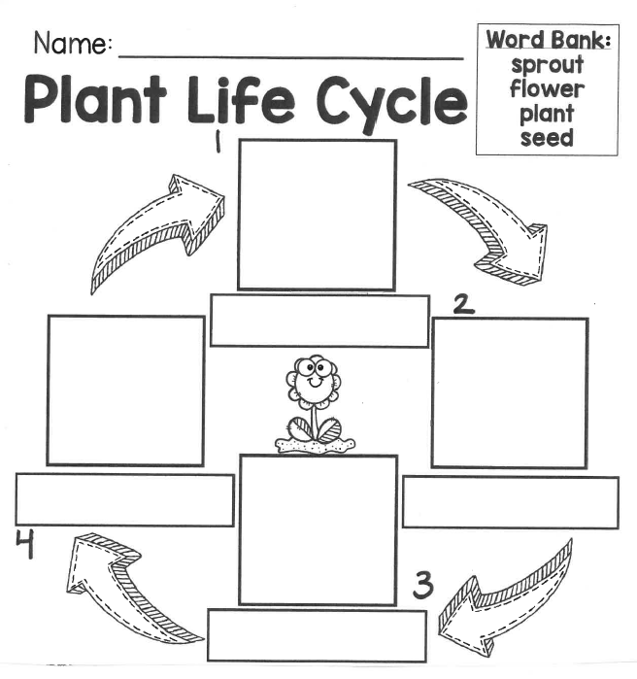

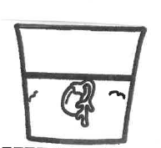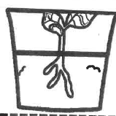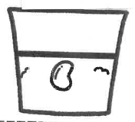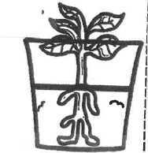

Constructed Response

- Why do people need plants?
________________________________________________________________

________________________________________________________________

________________________________________________________________

________________________________________________________________

- How do plants and animals need each other?
________________________________________________________________

________________________________________________________________

________________________________________________________________

________________________________________________________________

