Kindergarten Unit 4 Assessment

Name: _______________________________________________________________________
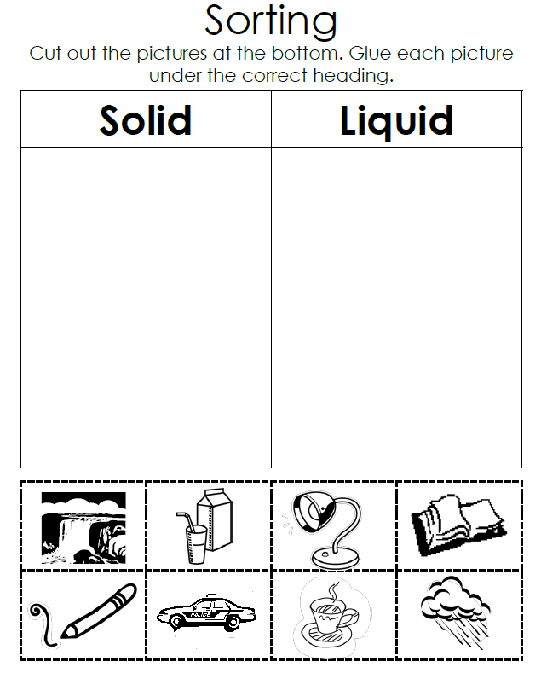

Constructed Response

How does a solid become a liquid? Draw or describe.

