Unit 5 Animal Communication: Senses and Survival
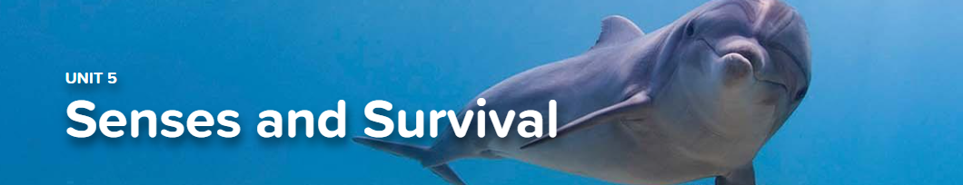

Concept 5.1 Adaptation and Survival
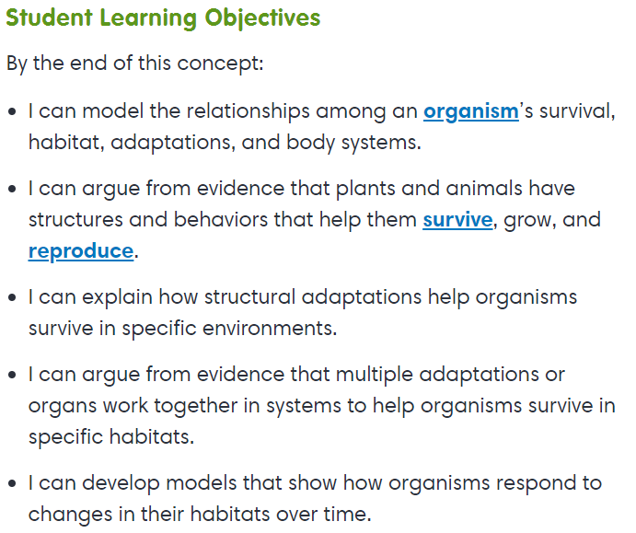
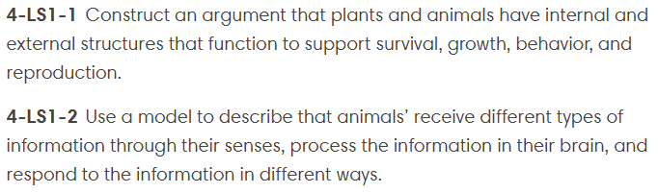

Virtual Lab
Featuring Frogs

Interactive
Moth of a Different Color

Concept 5.2 Senses at Work
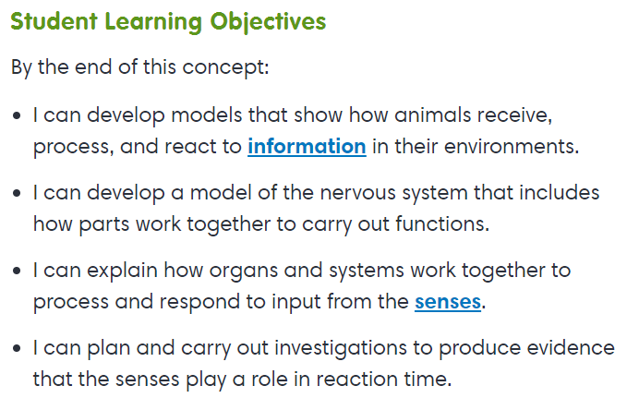
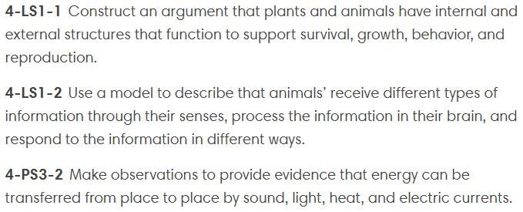

Exploration
Nervous System
Nerves

Concept 5.3 Light and Sight
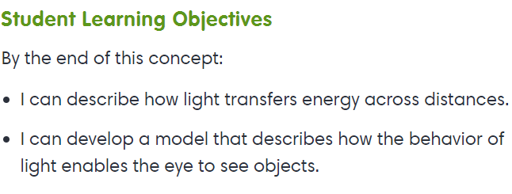
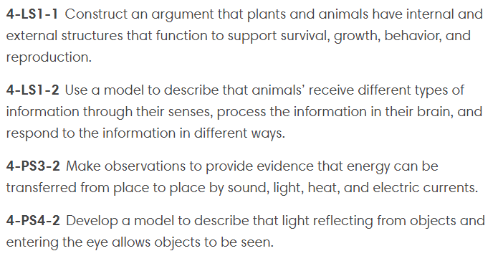

Virtual Lab
Reflection

Concept 5.4 Communication and Information Transfer
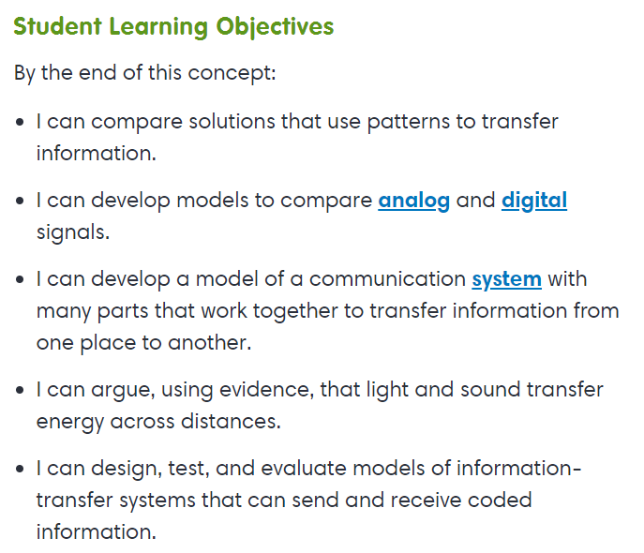
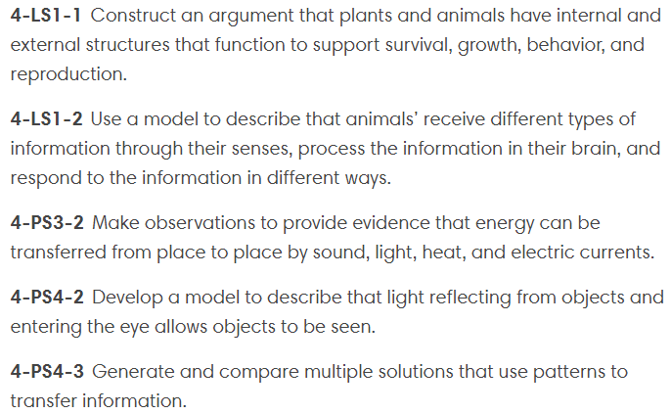

- Data / Graph Tool – Create a graph using your own set of data

