Grade 4 Unit 4 Waves in Action: Earthquakes
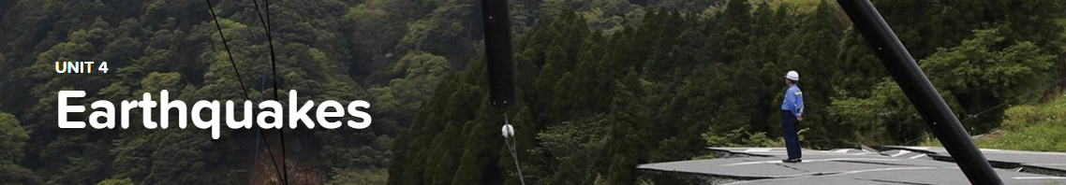

Concept 4.1 Earthquake Causes and Impacts
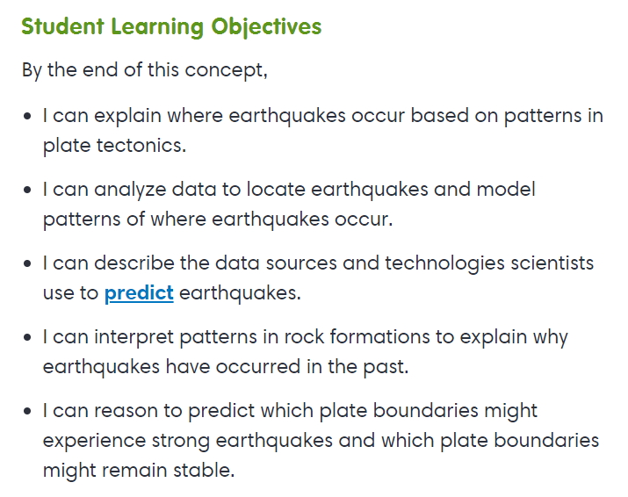
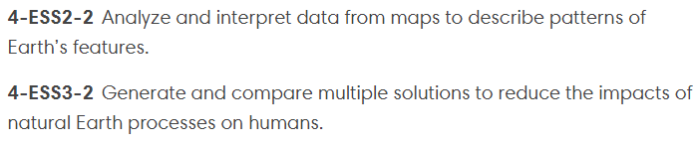

Concept 4.2 Earthquake Waves
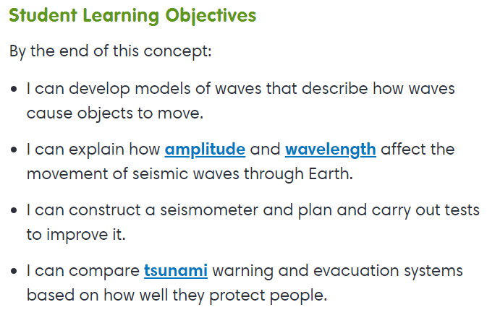
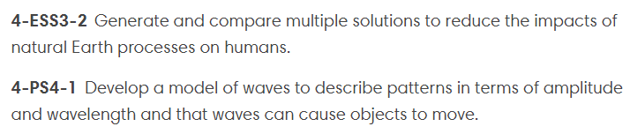

Exploration
Find the Temblor
Makin’ Waves

Concept 4.3 Reducing Earthquake Impacts
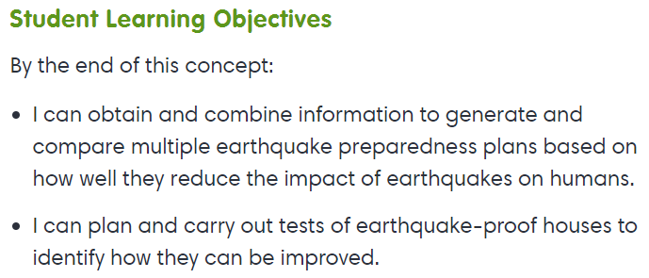
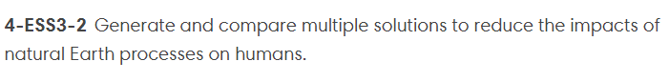

Interactive
How It Shakes Out

