Grade 4 Unit 3 Earth’s Changing Surface
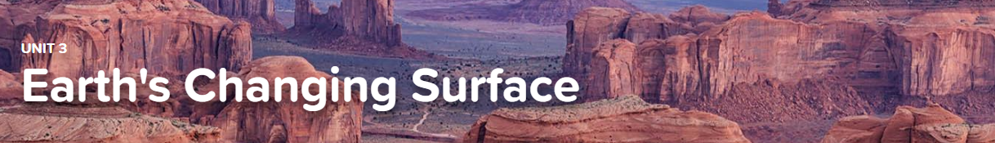

3.1 Breaking Down and Moving Rocks
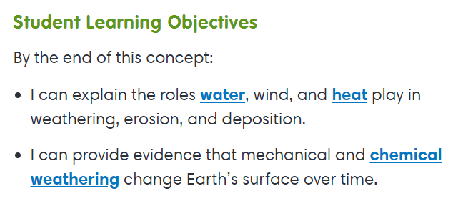
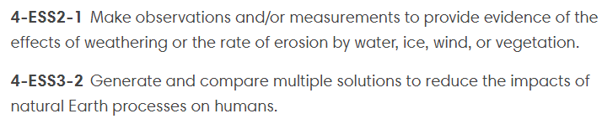

Virtual Lab
Here Today, Gone Tomorrow
Interactive
Forces That Shape the Earth

3.2 Changing Landscapes
3.3 Mapping Landforms
Exploration
Landforms

3.4 Volcanoes
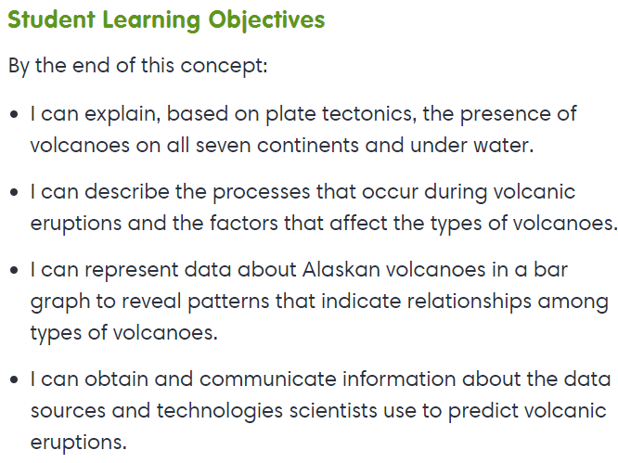
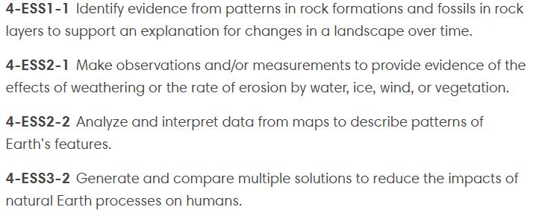

- Exploration Make Volcanoes Erupt
- Exploration Volcanoes

