Grade 4 Unit 2 Energy Resources
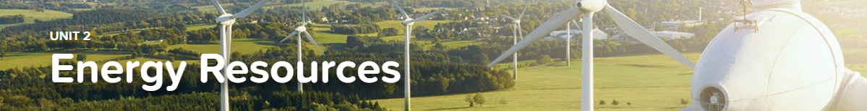

2.1 Devices and Energy
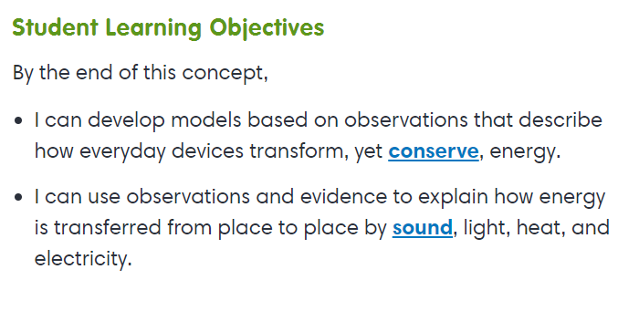
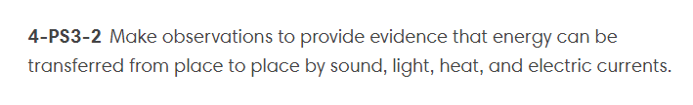
Exploration
Changing the Form of Energy

2.2 About Fuels
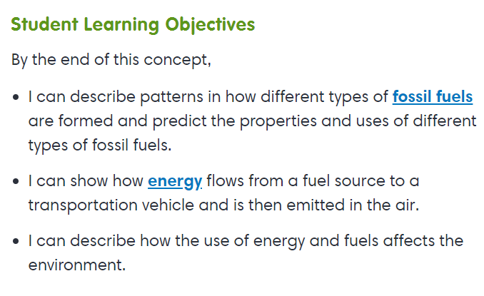
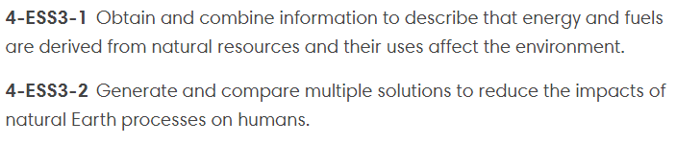
Virtual Lab
Fossil Fuels
Interactive
Value of Renewable Resources

2.3 Renewable Energy Resources
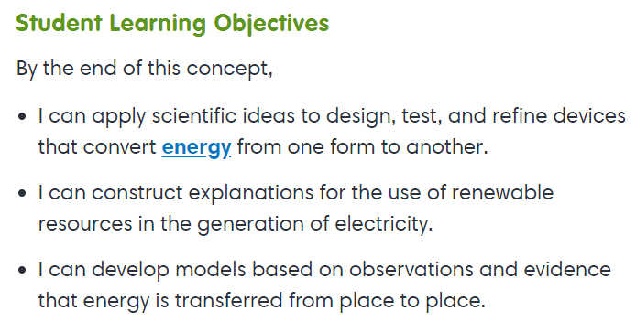
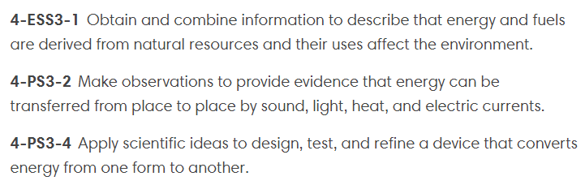

Virtual Lab
Wow! Windmills!
Interactive
Sunlight

2.4 Energy and the Environment
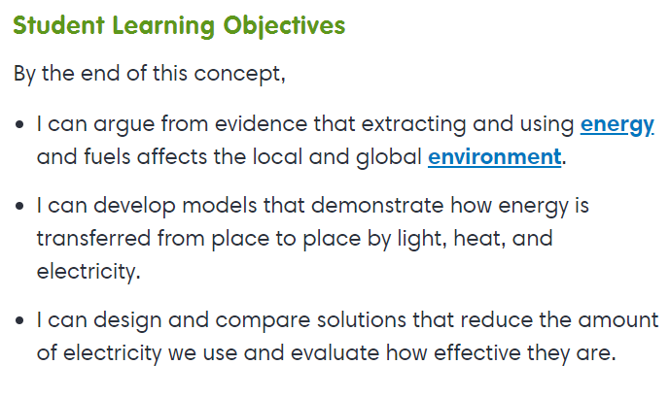
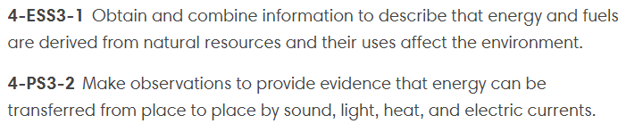

Virtual Lab
How Big Is Your Footprint?

