Unit 1 Motion: Car Crashes
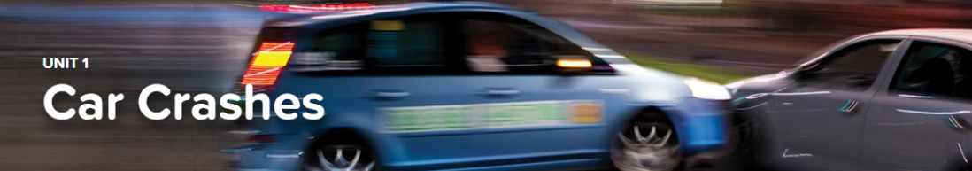

Concept 1.1 Starting and Stopping
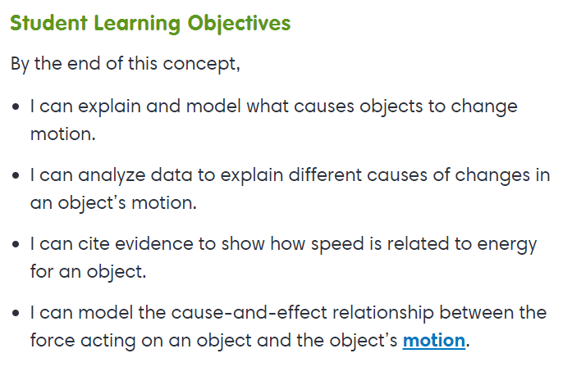
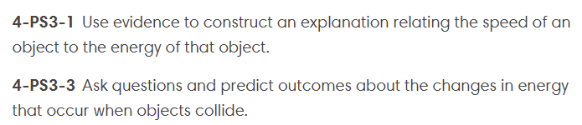
Virtual Lab
Changing Direction

Concept 1.2 Energy and Motion
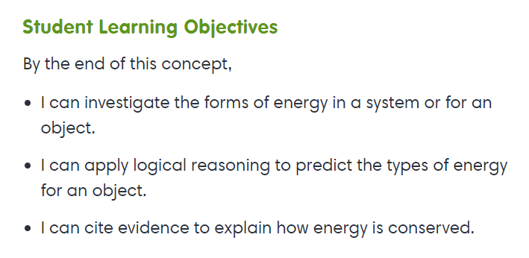
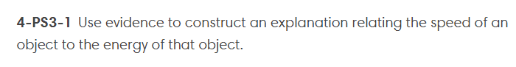
Interactive
Forms of Energy
Interactive
Energy Makes It Happen
Exploration
Types of Simple Machines

Concept 1.3 Speed
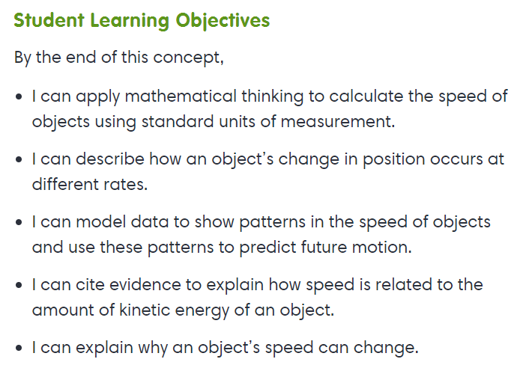
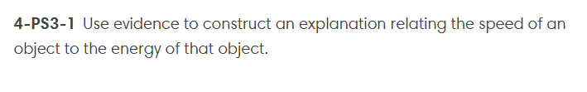
Virtual Lab
Racing RC Cars
Exploration
Describing Motion

Concept 1.4 Energy and Collisions
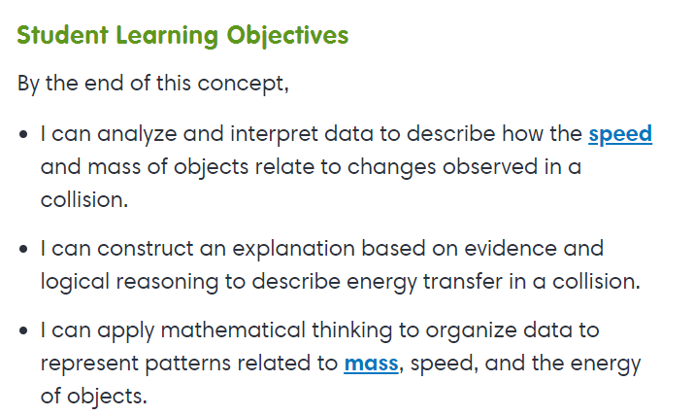
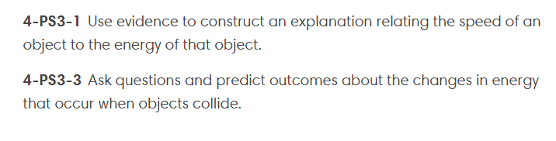

Exploration
Changing the Speed of Motion

