Grade 3 Unit 4: Weather Impacts
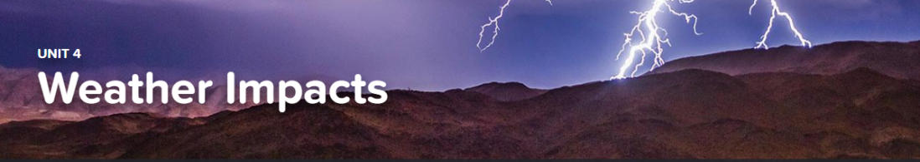

Concept 4.1 Regional Climates
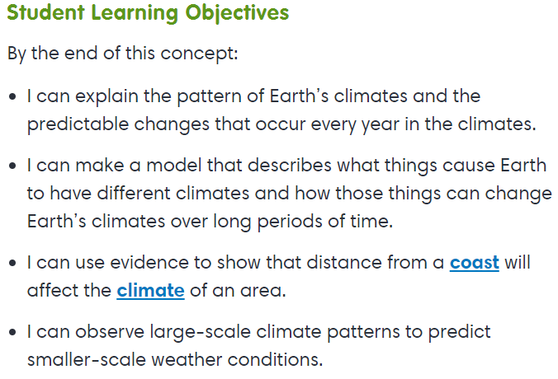
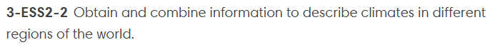

Exploration
- Exploring Regional Climates
- Types of Climates

Interactive
- About Climate

Concept 4.2 Predicting Weather
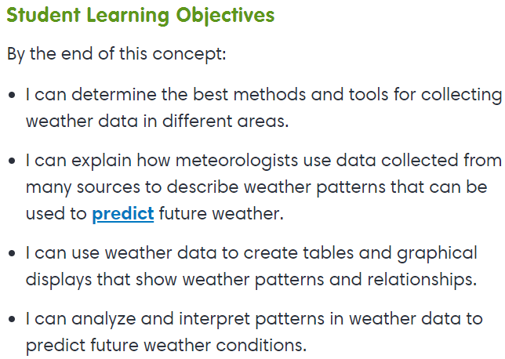
Interactive
- Weather Data

Exploration
- About Weather

Virtual Lab
- What Shall We Do Tomorrow?

Fun-damental
- Under the Weather

Concept 4.3 Weather Hazards
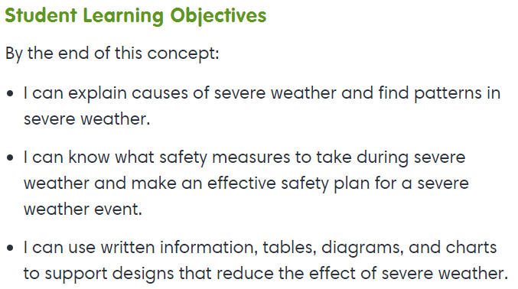
Exploration
- Hurricanes

