Grade 3 Unit 3: Surviving in Changing Environments
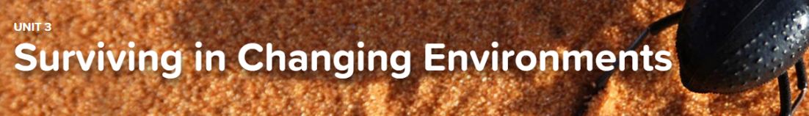

Concept 3.1 Understanding Fossils
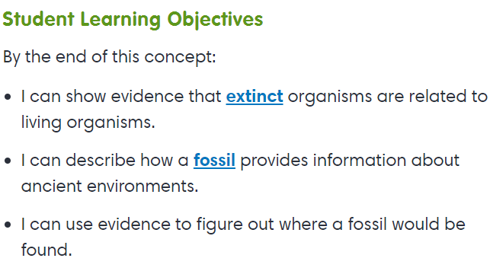
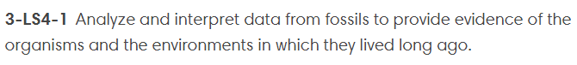
Interactive
- Earth History

Exploration
- Extinction

Virtual Lab
- No Bones About It

Concept 3.2 Interactions in the Environment
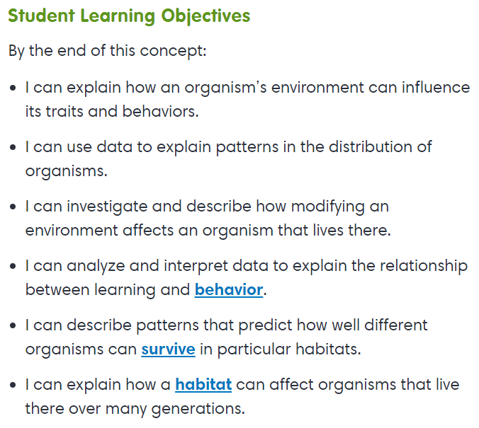
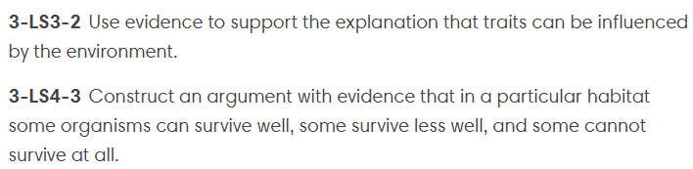
Interactive
- Habitat Characteristics
- Organism Needs
- Learning (learned behavior)
- Interactions in Ecosystems

Concept 3.3 Environmental Changes
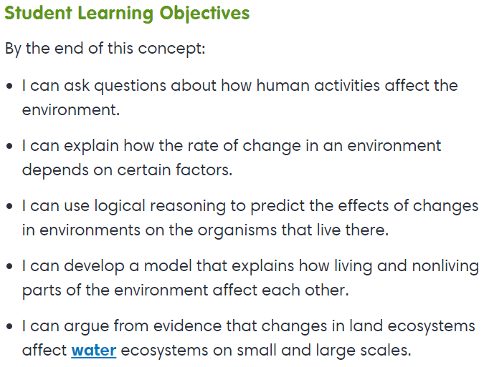
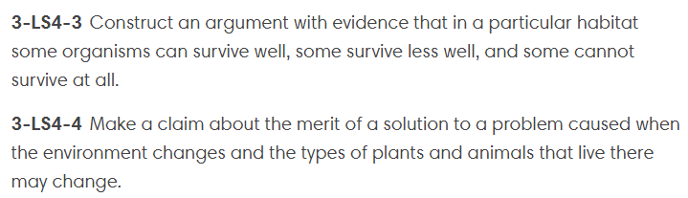
Exploration
- Short-Term Changes
- Population Changes

Interactive
- Long-Term Changes in Ecosystems

Virtual Lab
- Pond-er This

