Grade 3 Unit 2: Life Cycles for Survival
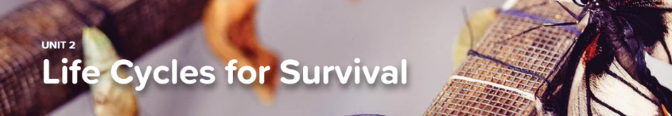
Concept 2.1 Life Cycles
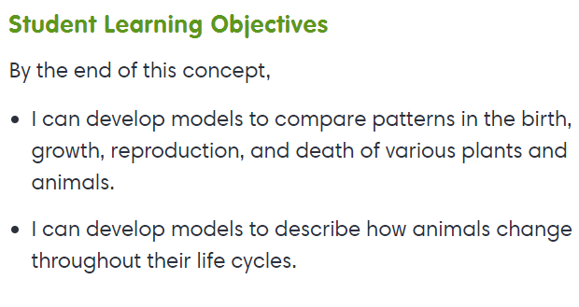
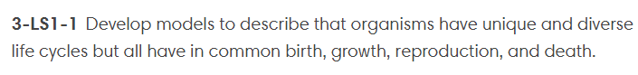
Interactive
- Animals: Growing Up

Exploration
- Life Cycle Stages

Concept 2.2 Inherited Traits
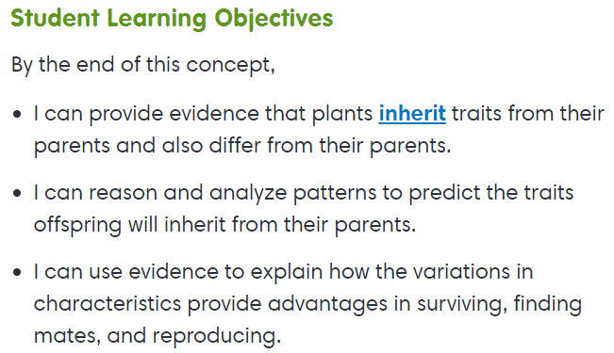

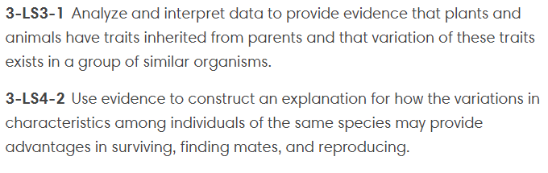
Interactive
- Similarities of Parents and Offspring
- Moth of a Different Color

Concept 2.3 Working in Groups
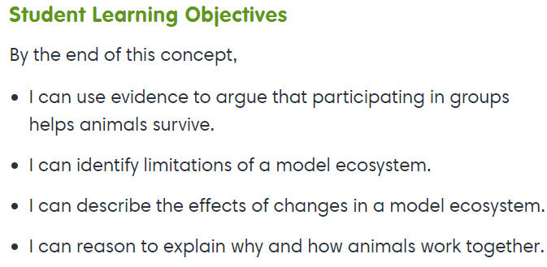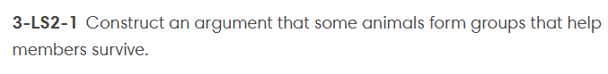
Interactive
- Needs of Living Things

