Grade 3 Unit 1: Playground Forces

Concept 1.1 Moving Objects
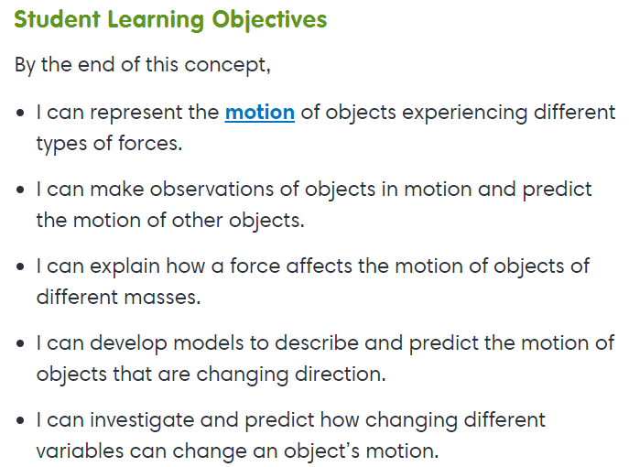
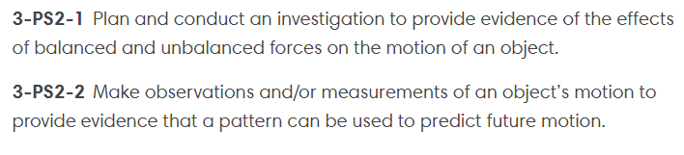

Interactives
- Gravity

Virtual Lab
- Changing Direction
- About Force
- Pulling Your Weight

Exploration
- Changing the Speed of Motion

Concept 1.2 Static Force
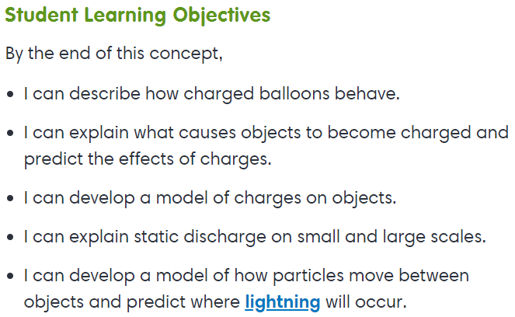
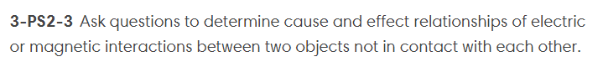

Exploration
- Static Electricity

Concept 1.3 Magnetic Force
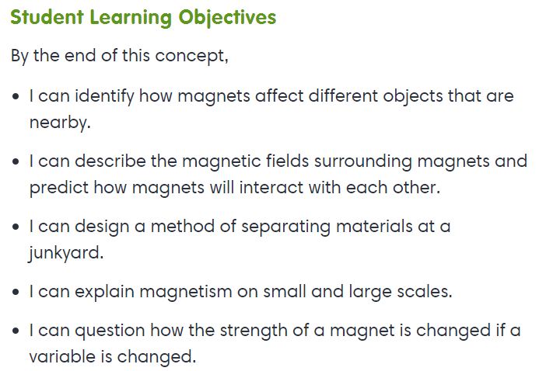
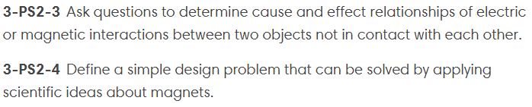
Exploration
- The Attraction is Mutual
- Magnets
- Magnets and Electricity

