Grade 2 Unit 4: Biodiversity in Habitats
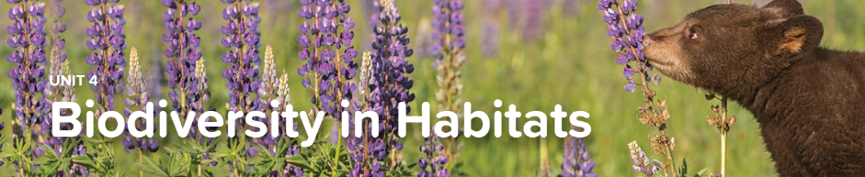
Concept 4.1 Living Landscapes
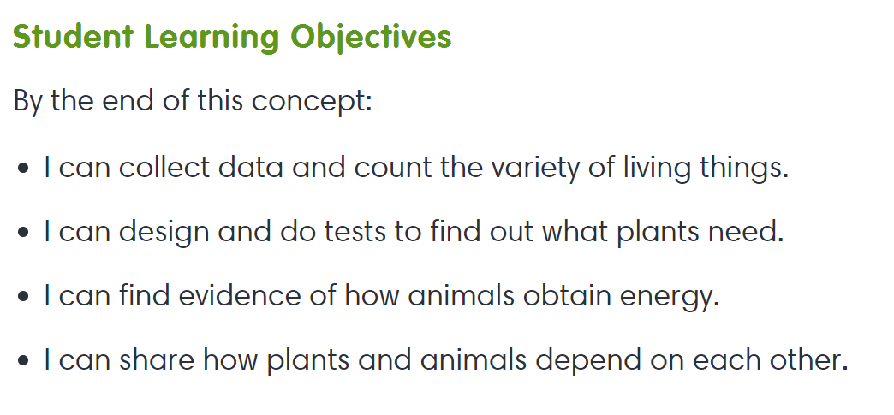
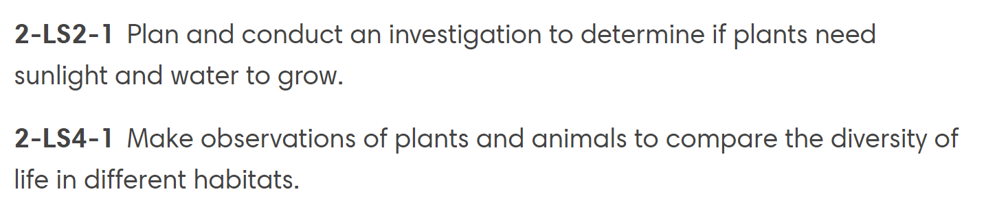
Interactives
- Needs of Living Things
- Getting to Know Plants
- Being Alive

Concept 4.2 Plants and Animals Relationships
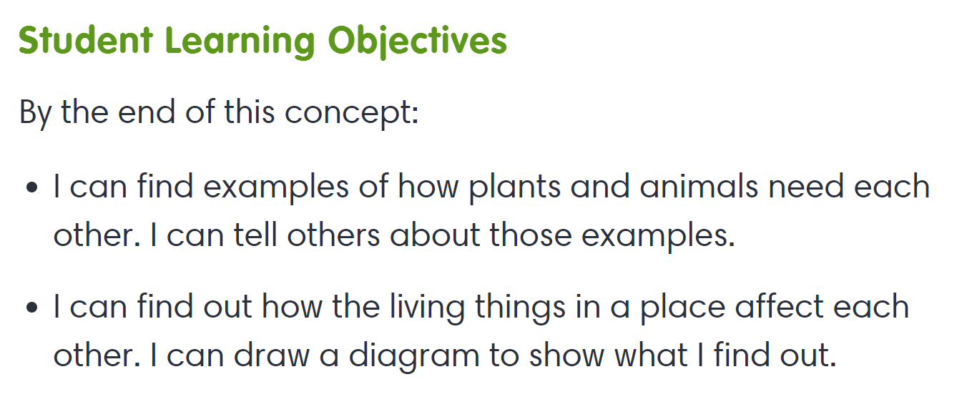
Interactives
- Organism Needs
- Earth’s Resources

