Grade 2 Unit 3: How Landscapes Change
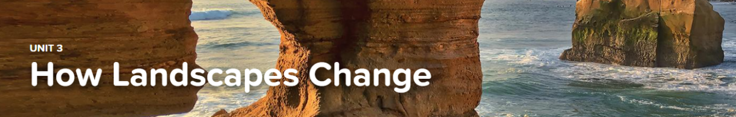
Concept 3.1: The Changing Landscape
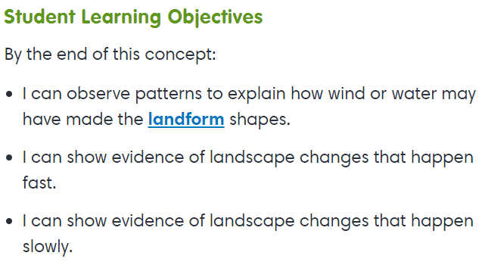
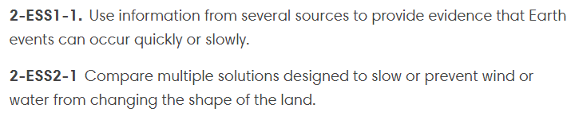

Exploration
- Erosion and Deposition
- Volcano
Interactive
- Waters of the Earth

Concept 3.2: Landscape Solutions
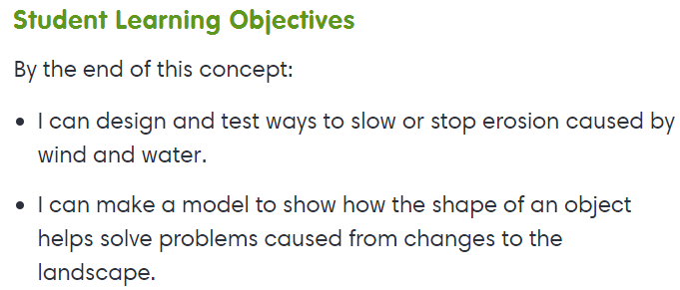

Virtual Lab
- Erosion - Here Today, Gone Tomorrow

