# Objects in the Sky

## Directions:

Think about what you see when you look outside **up in the sky** during the day. Draw a picture to show what you see. Then think about what you see when you look outside up in the sky at night. Draw a picture to show what you see at night.

|  |  |
| --- | --- |
| During the Day | At Night |
|  |  |

Write a sentence about what you see in the sky during the day.

|  |
| --- |
|  |
|  |

|  |
| --- |
|  |
|  |

Write a sentence about what you see in the sky at night.

|  |
| --- |
|  |
|  |

|  |
| --- |
|  |
|  |

# Objects in the Sky

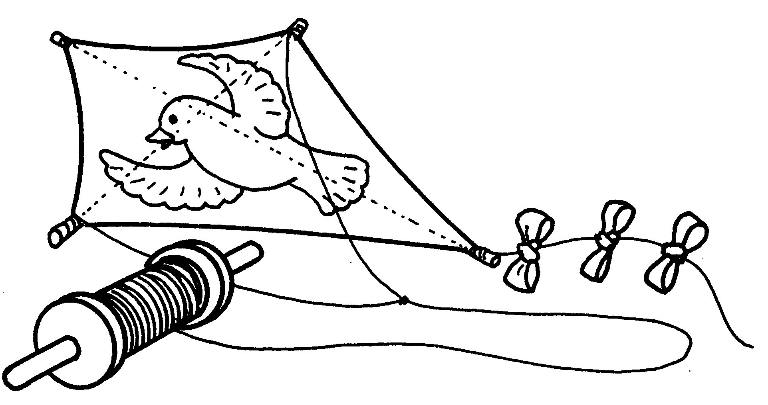

## Multiple Choice

1. It is night. Circle the picture that shows what you would see in the sky.

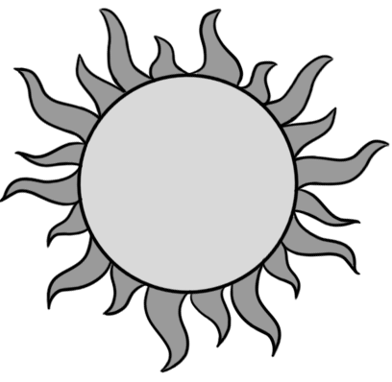 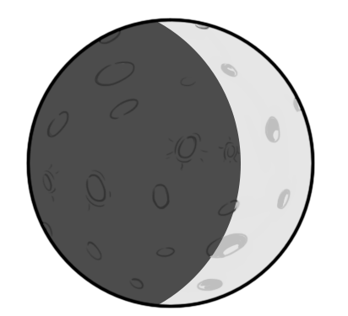 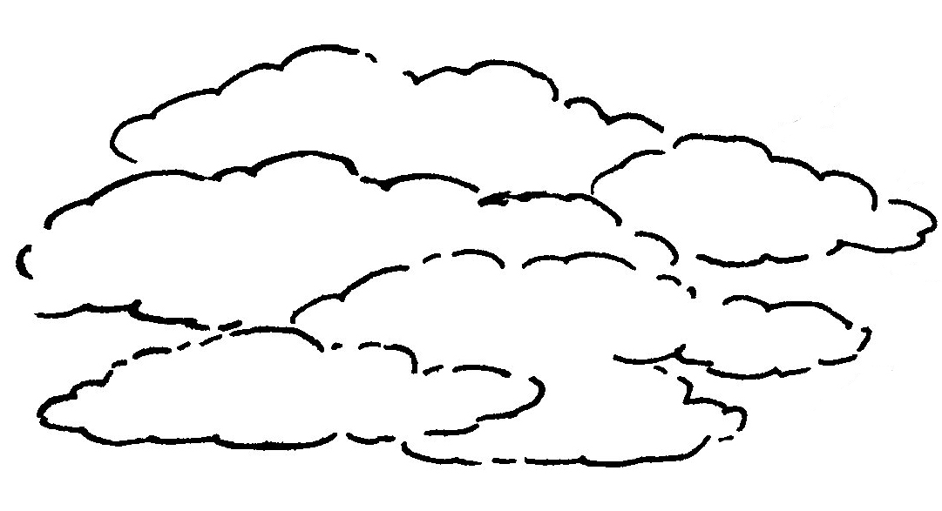 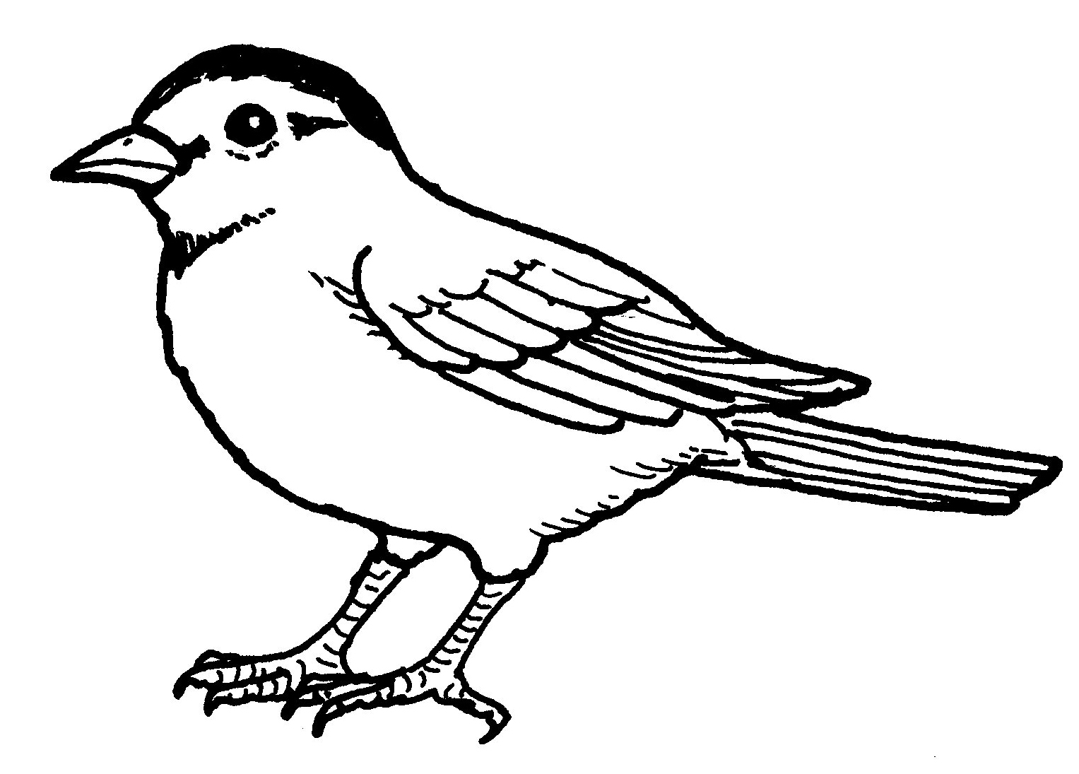

1. Circle the picture that shows why the girl is wearing the hat and bathing suit.

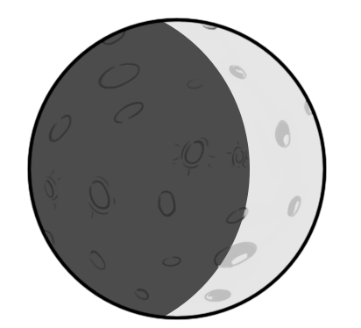

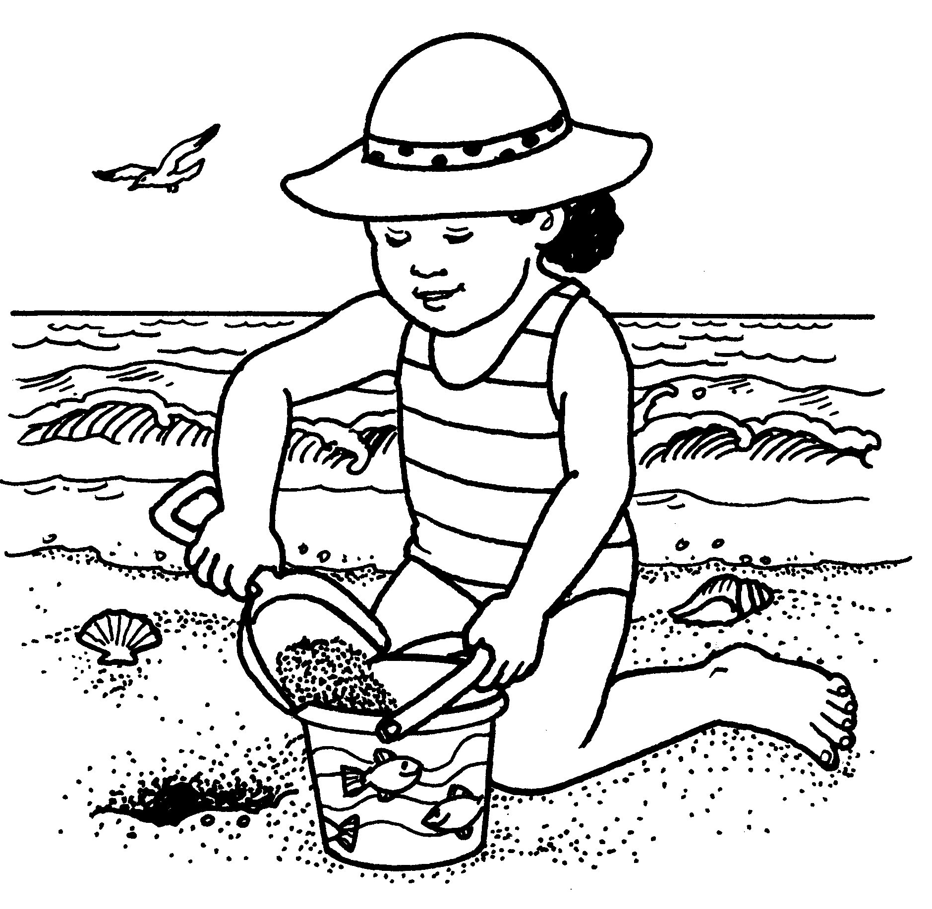 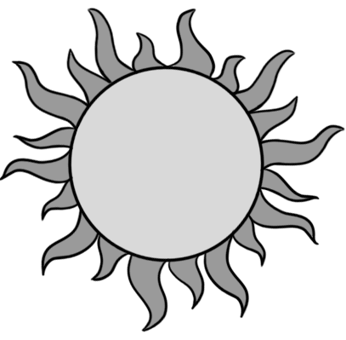

# Objects in the Sky

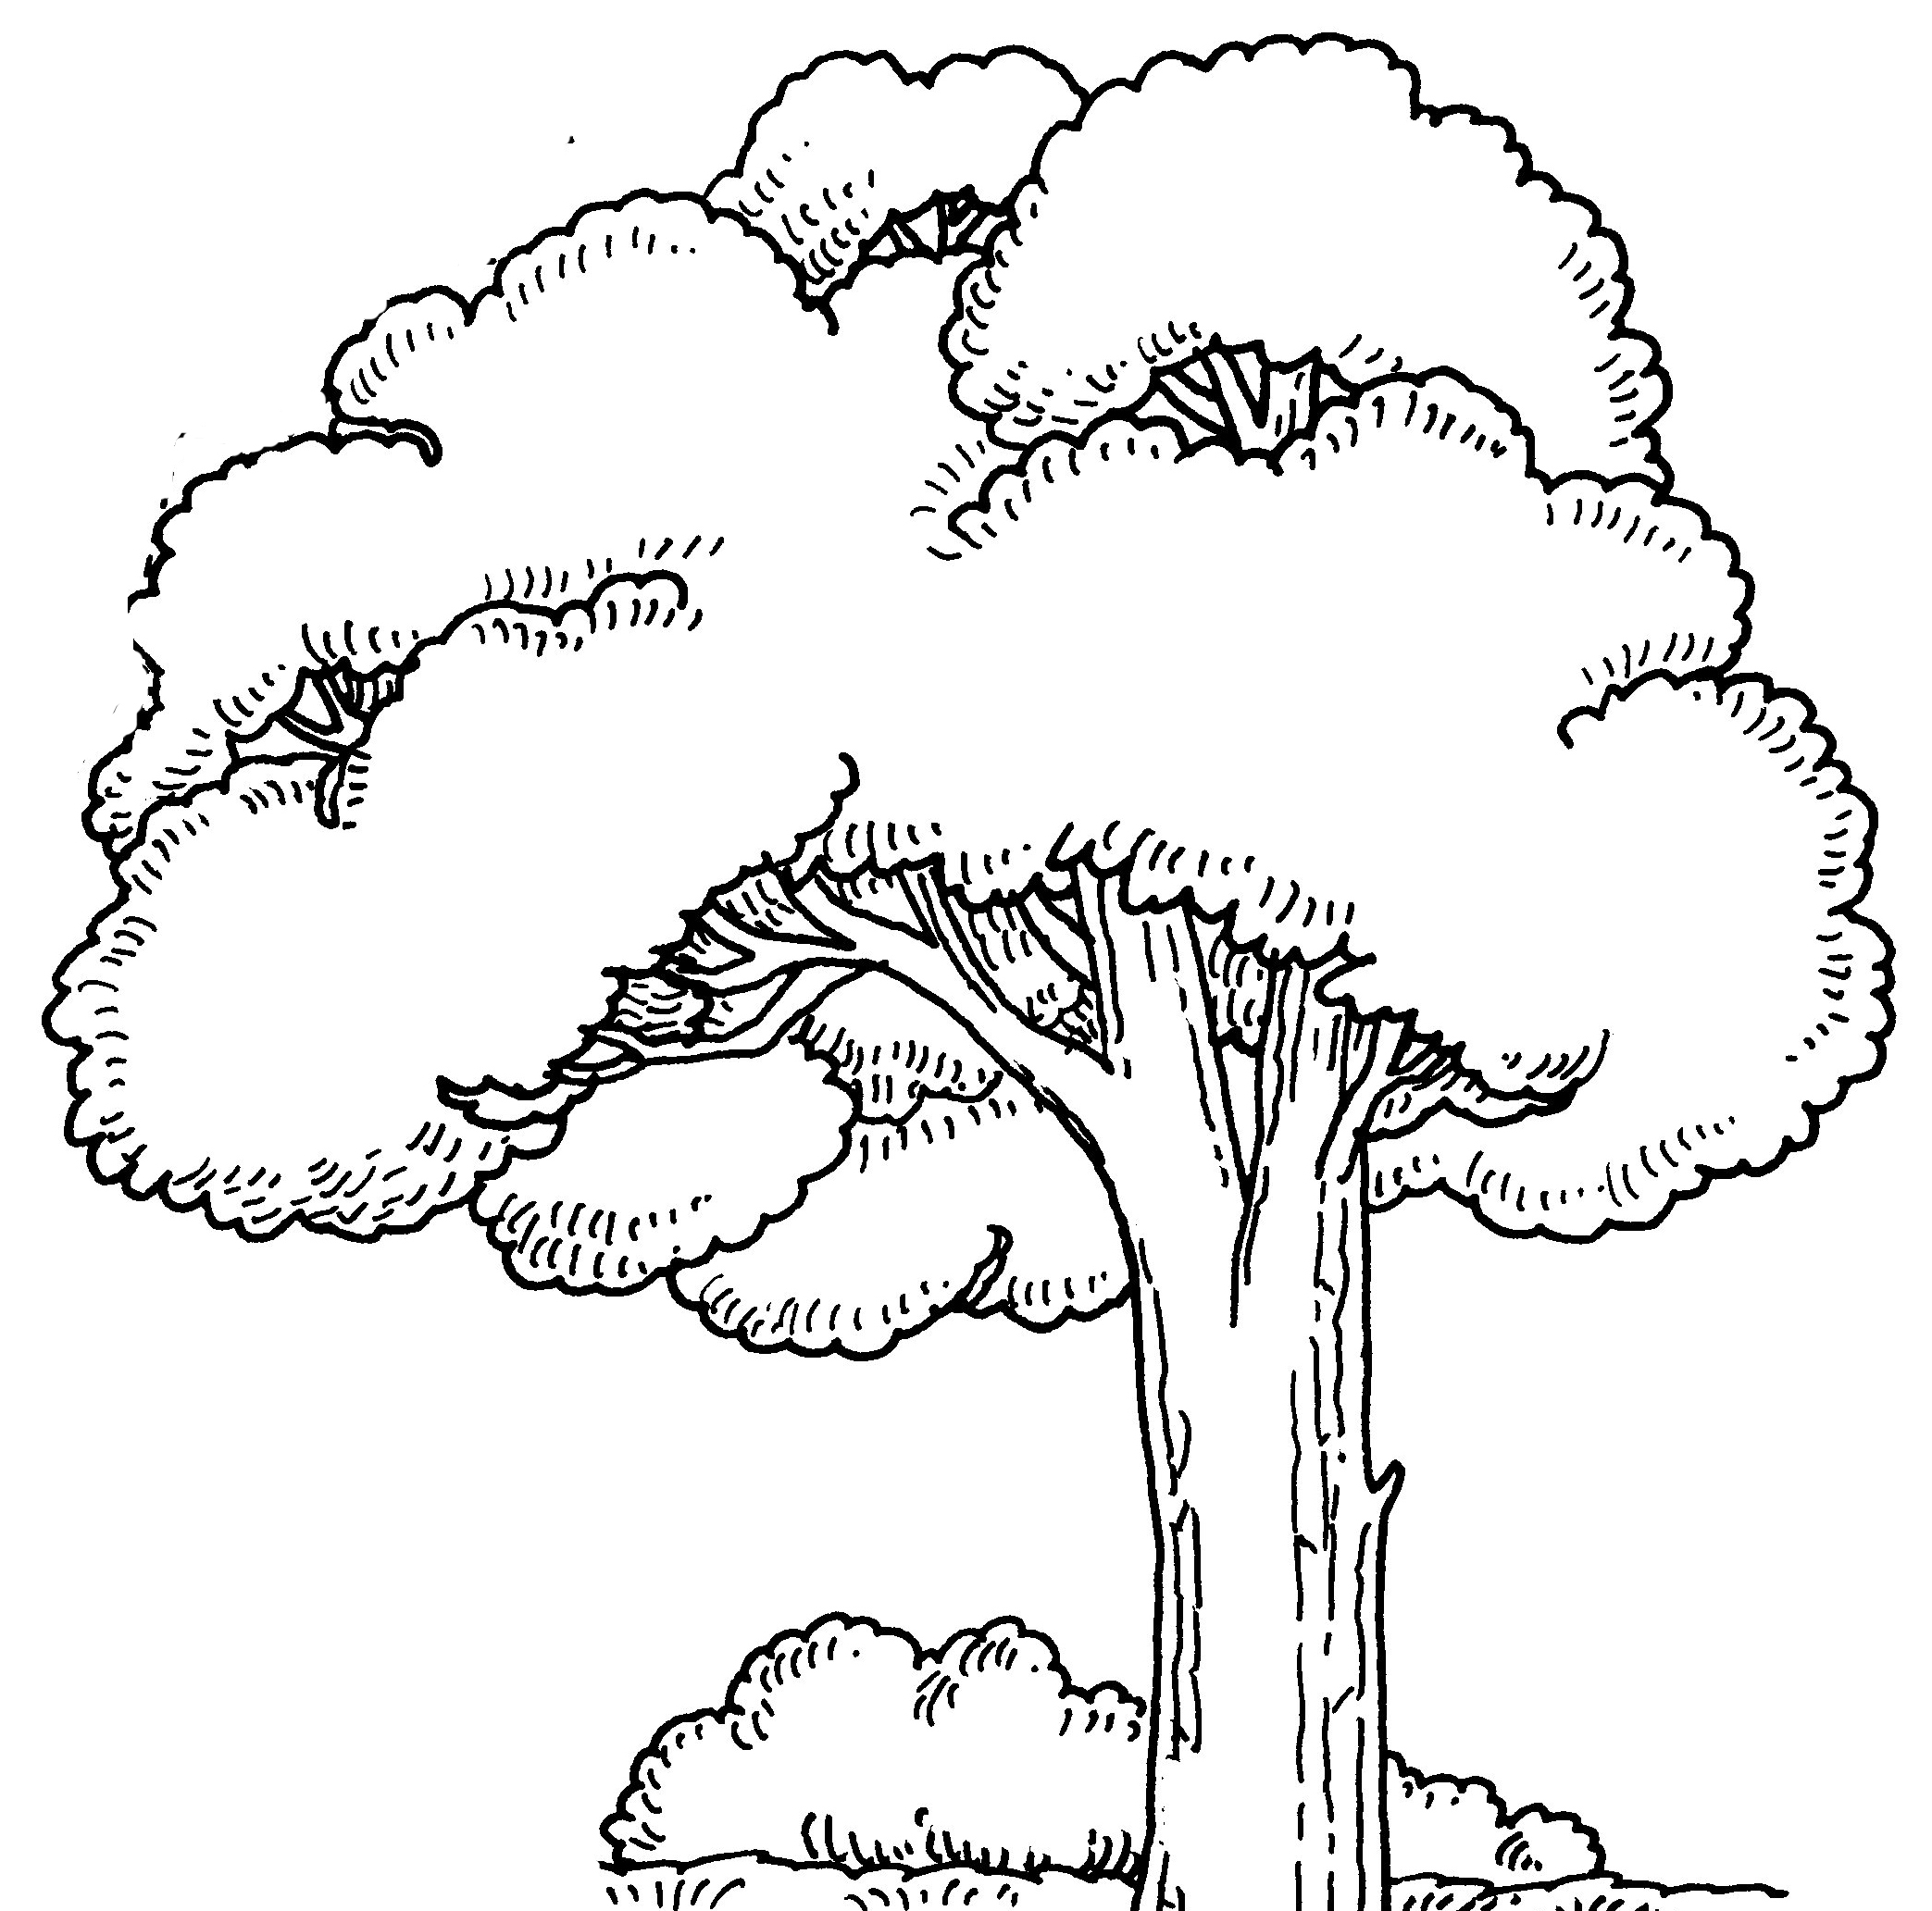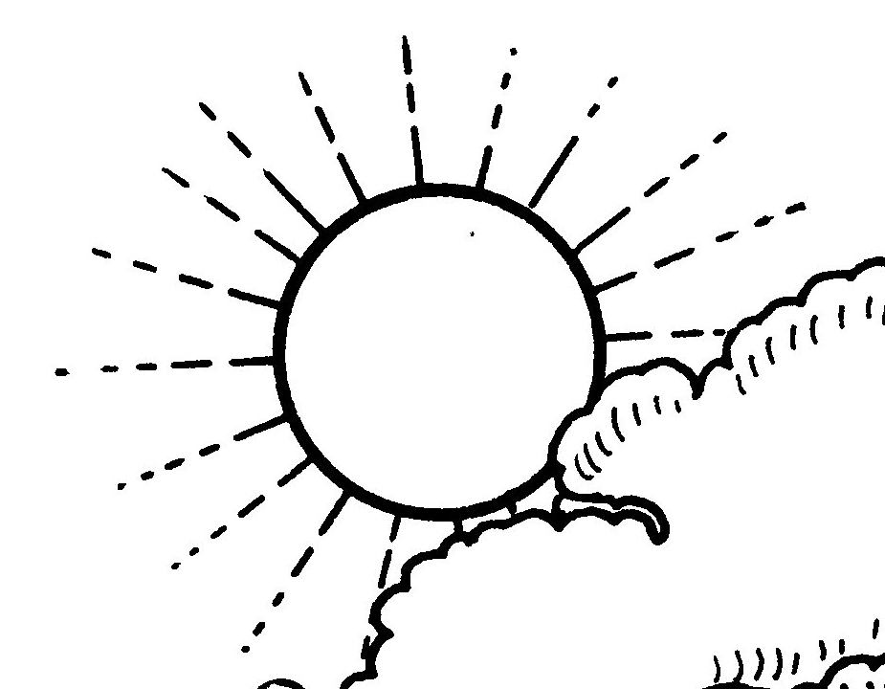

1. Circle the picture that shows an object that is far away from the boy.

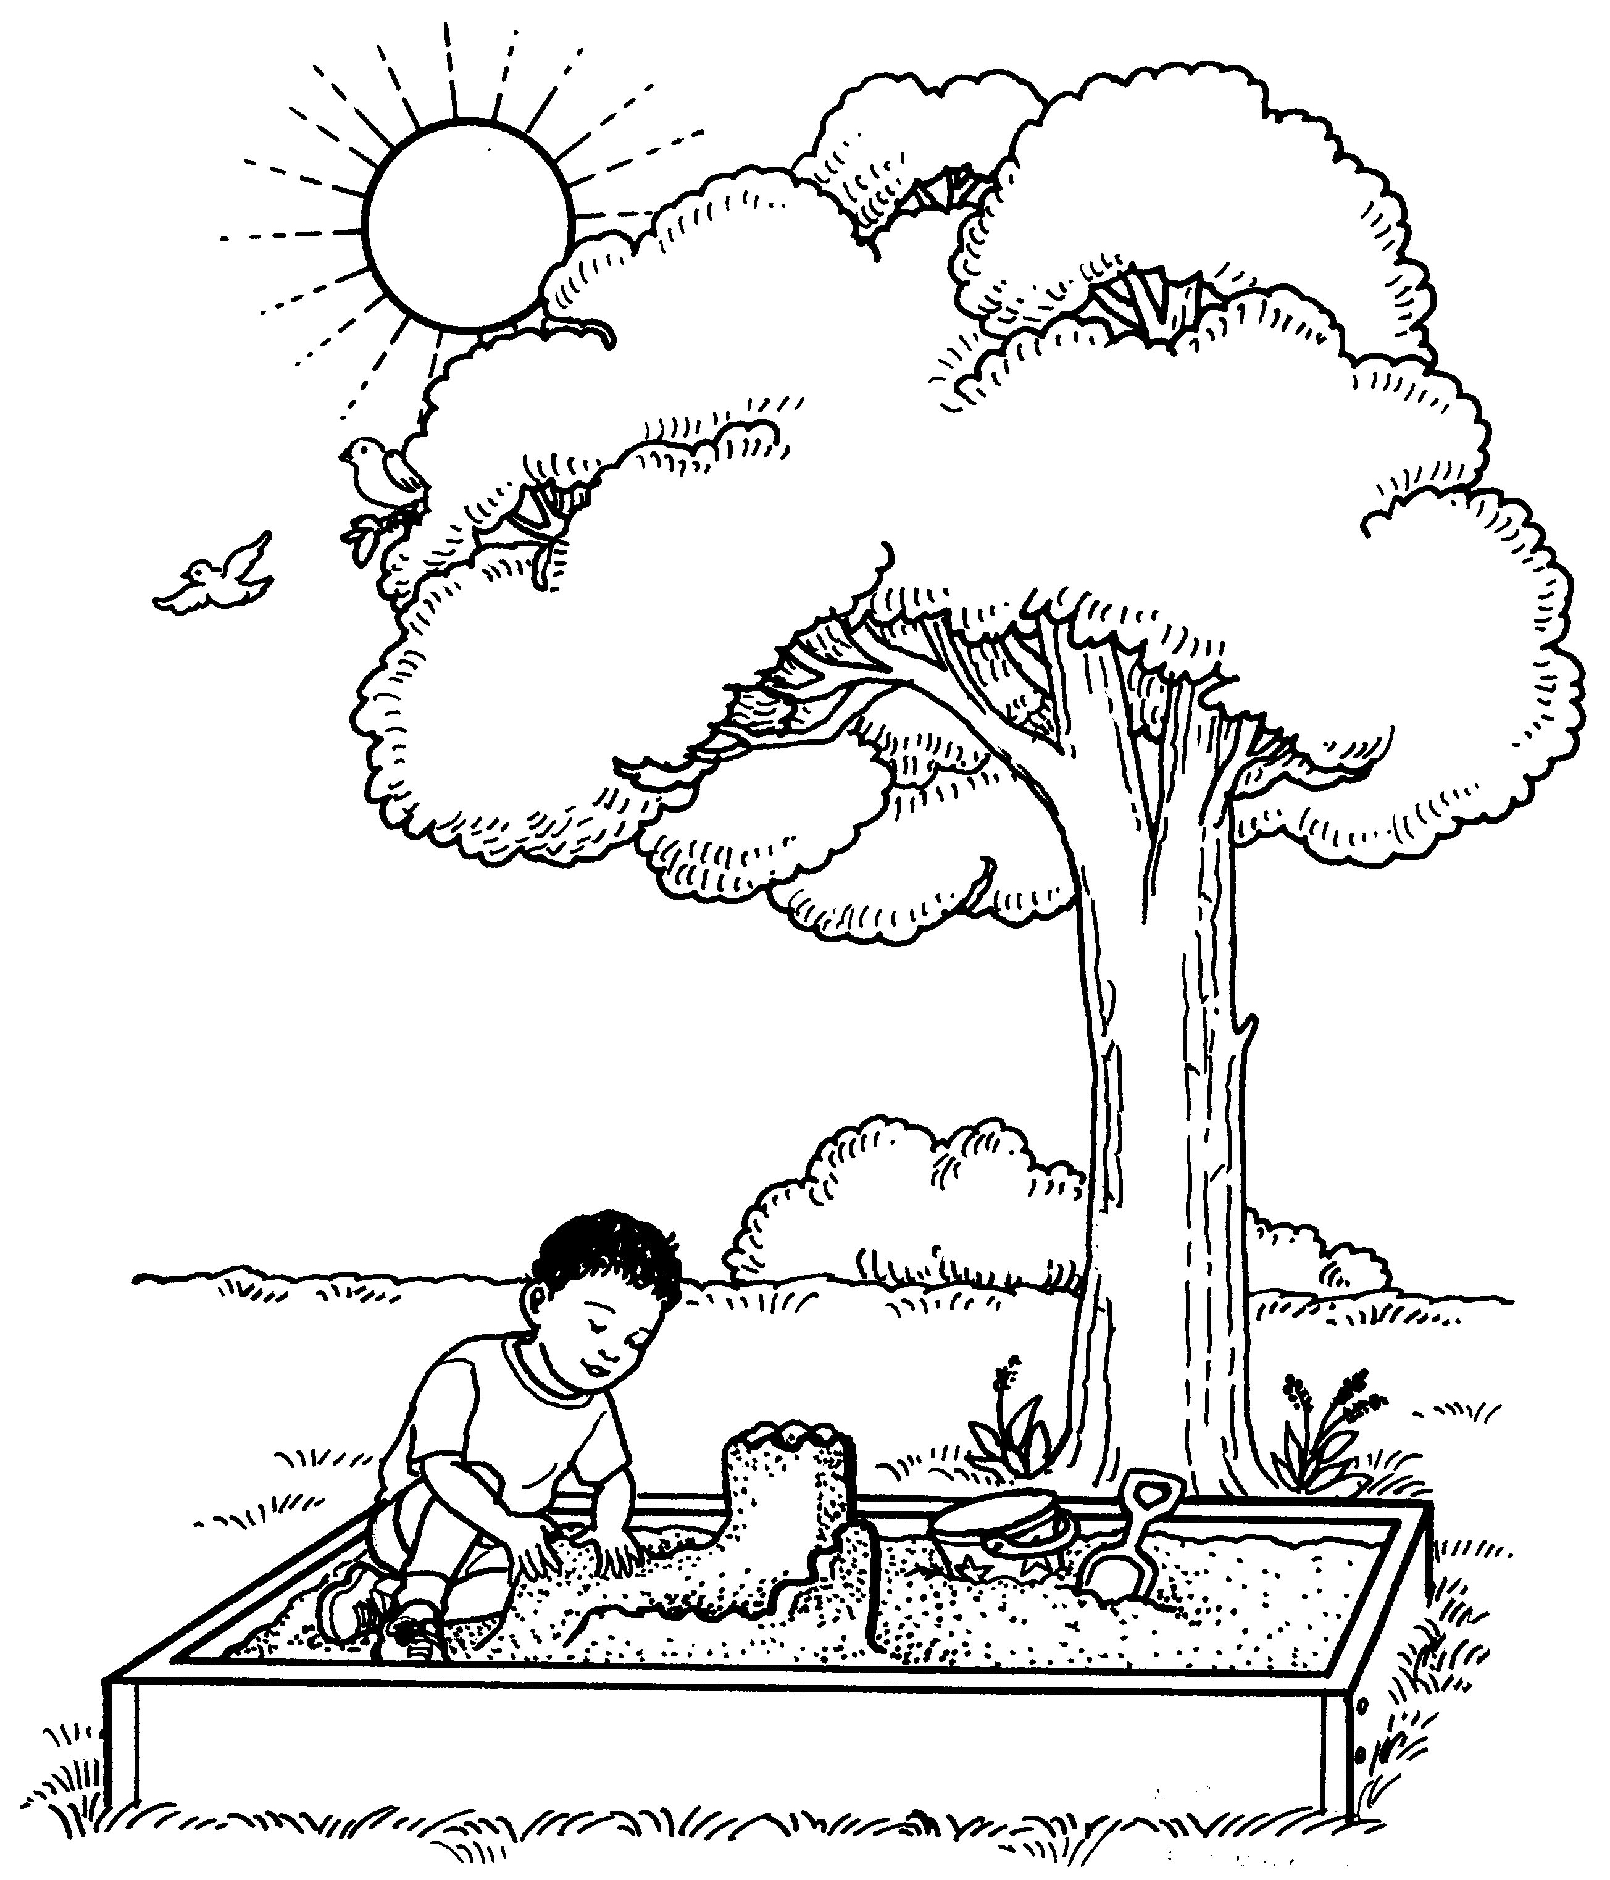 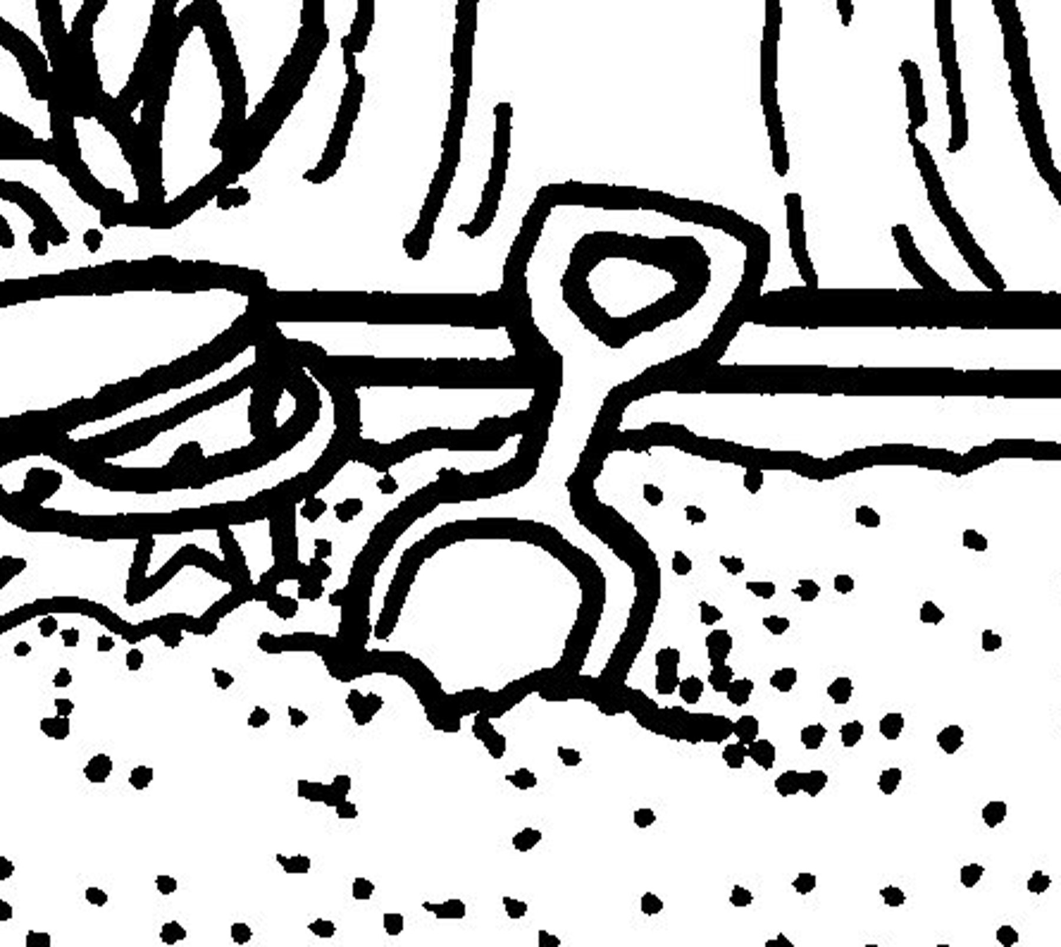 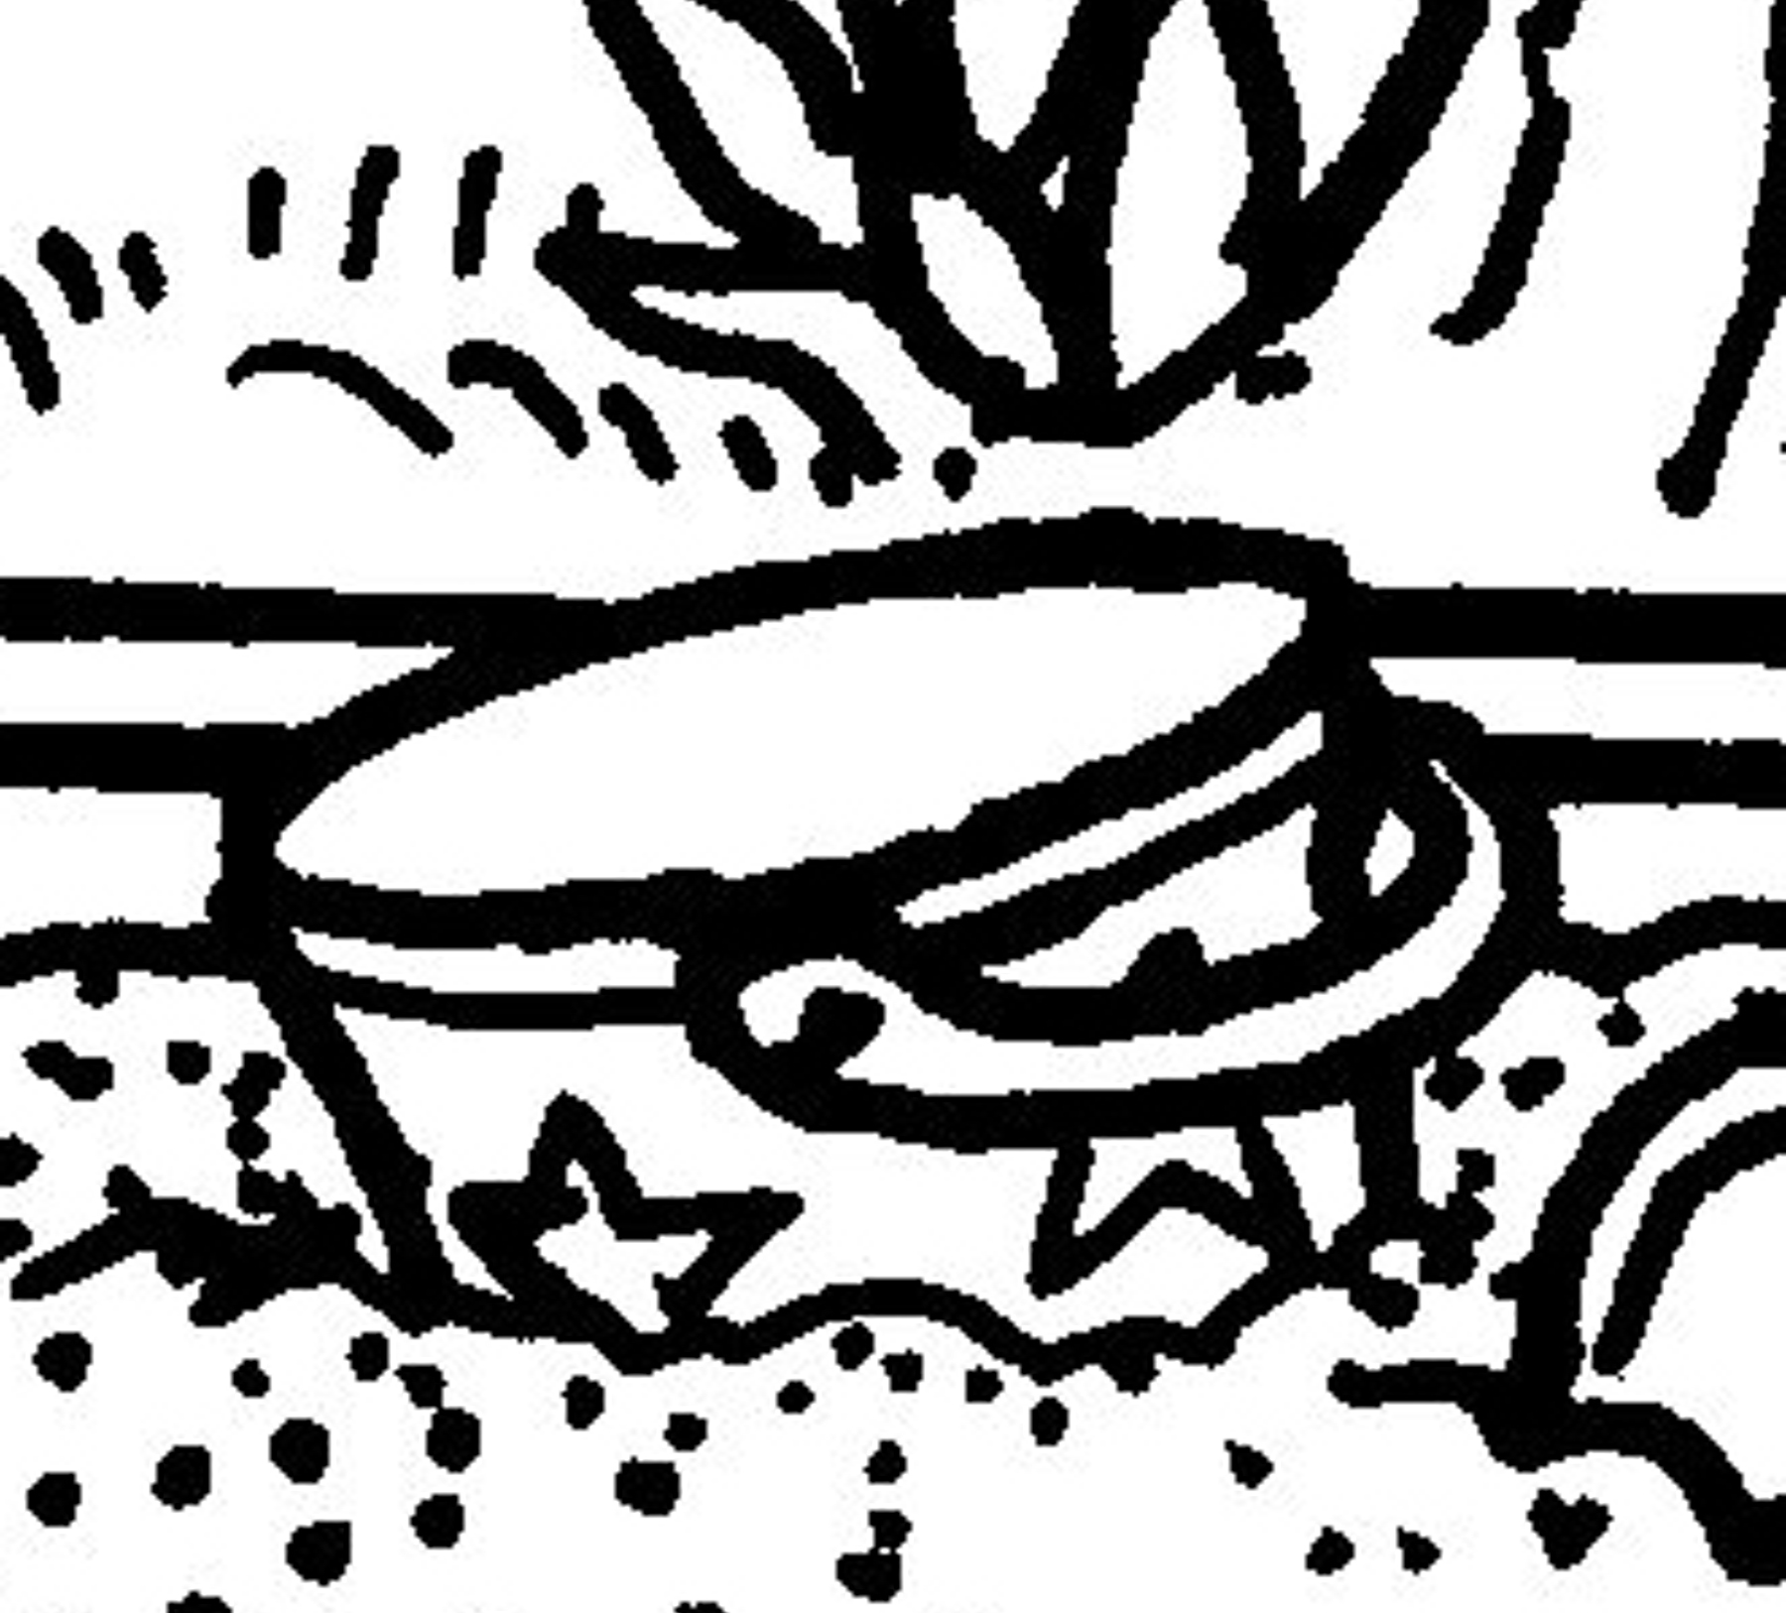

# Objects in the Sky

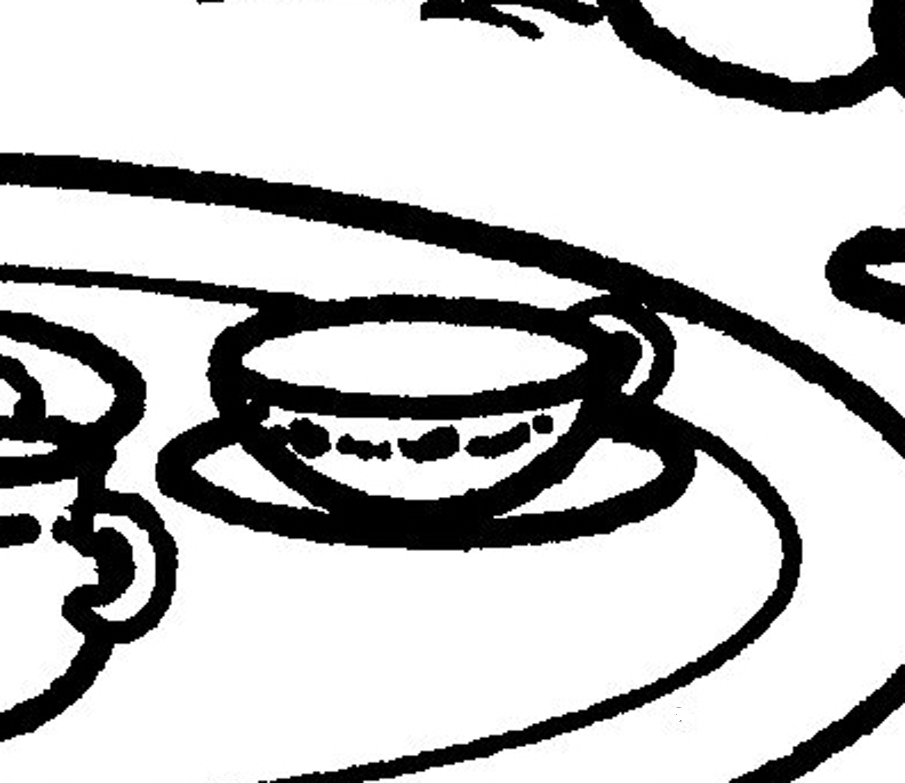

1. Circle the object that is small enough to fit in your hand.

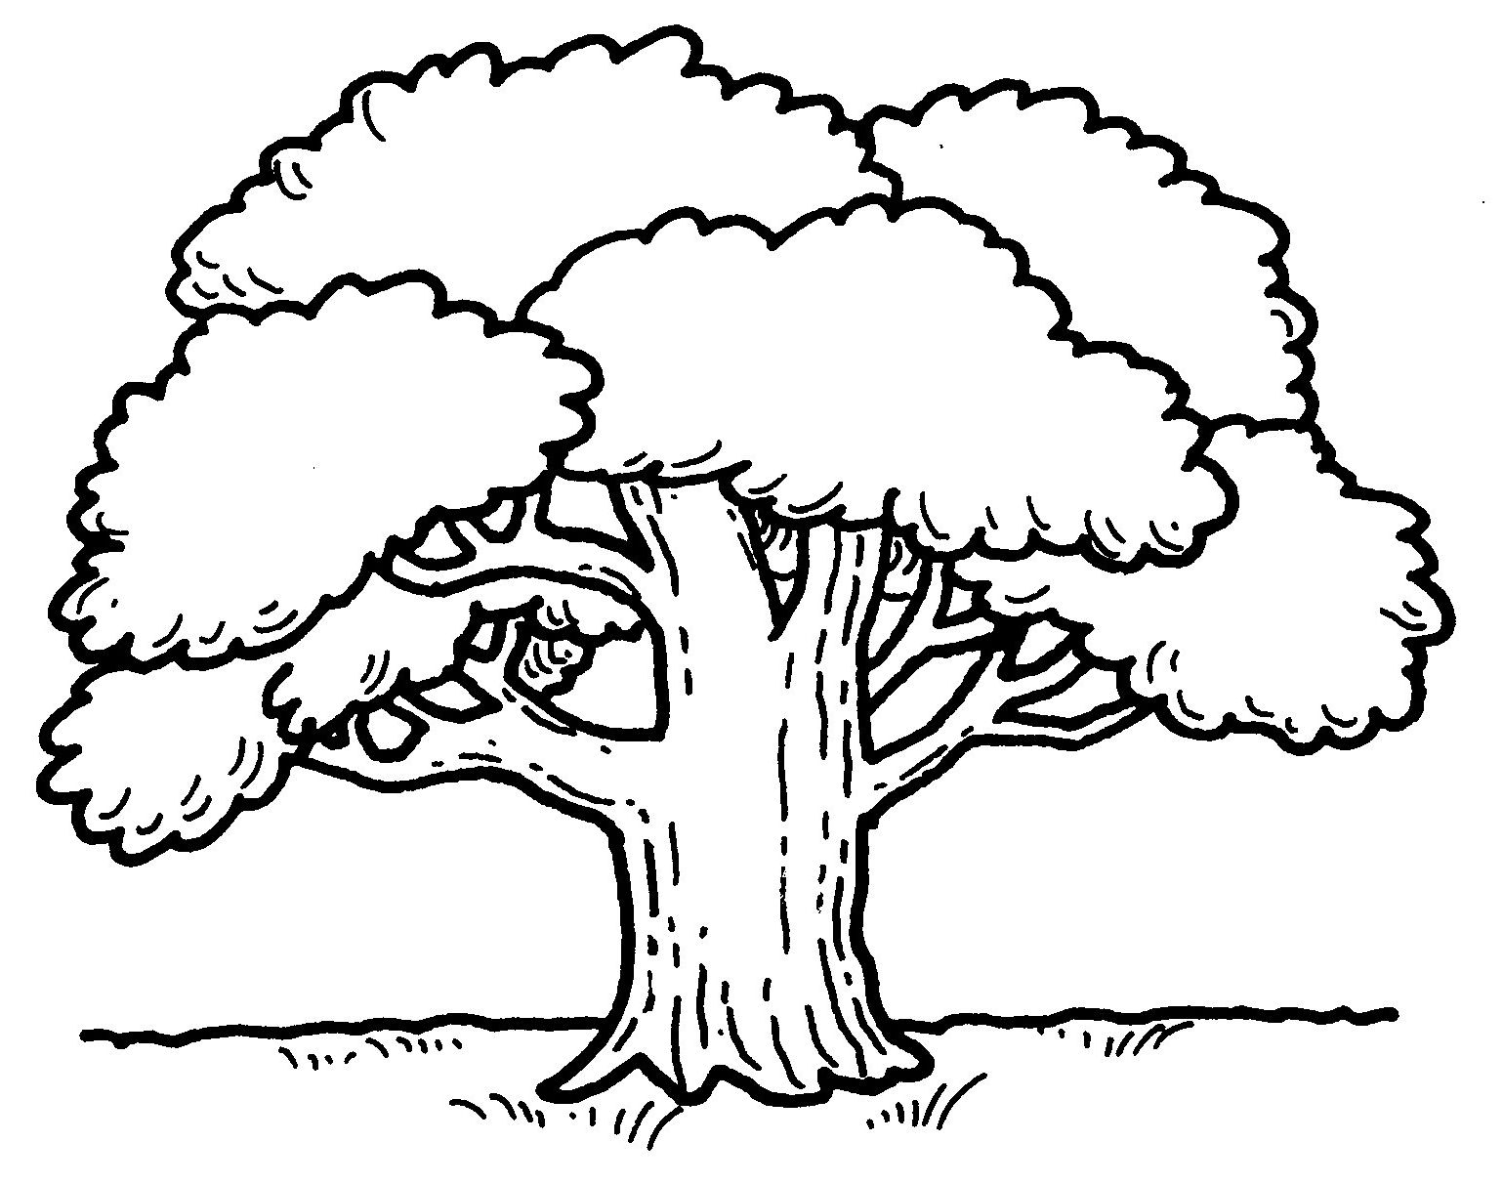 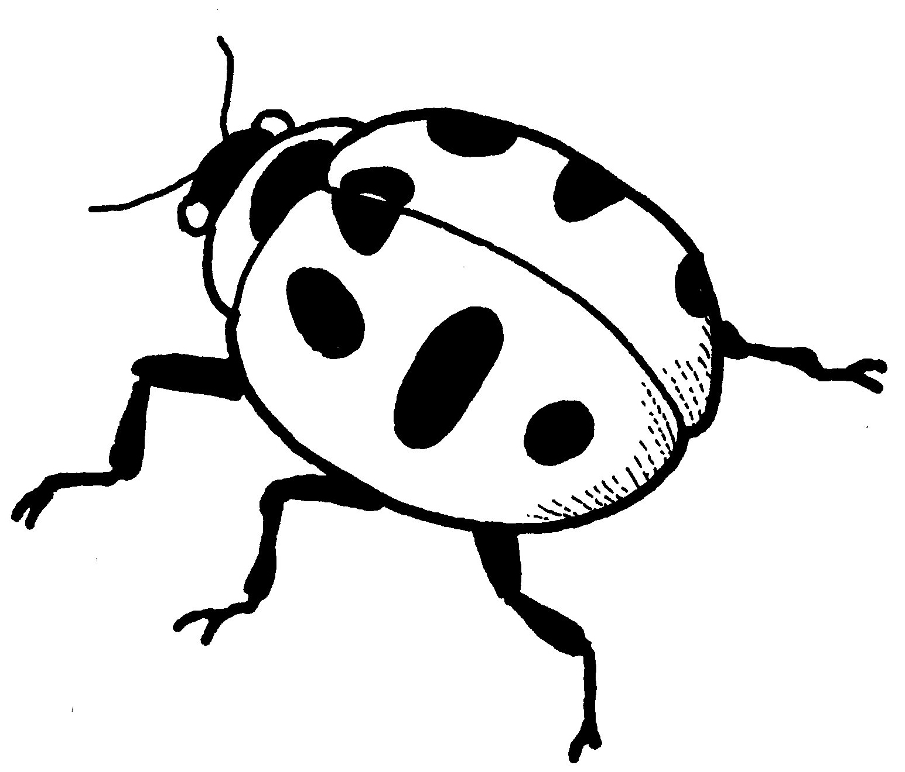 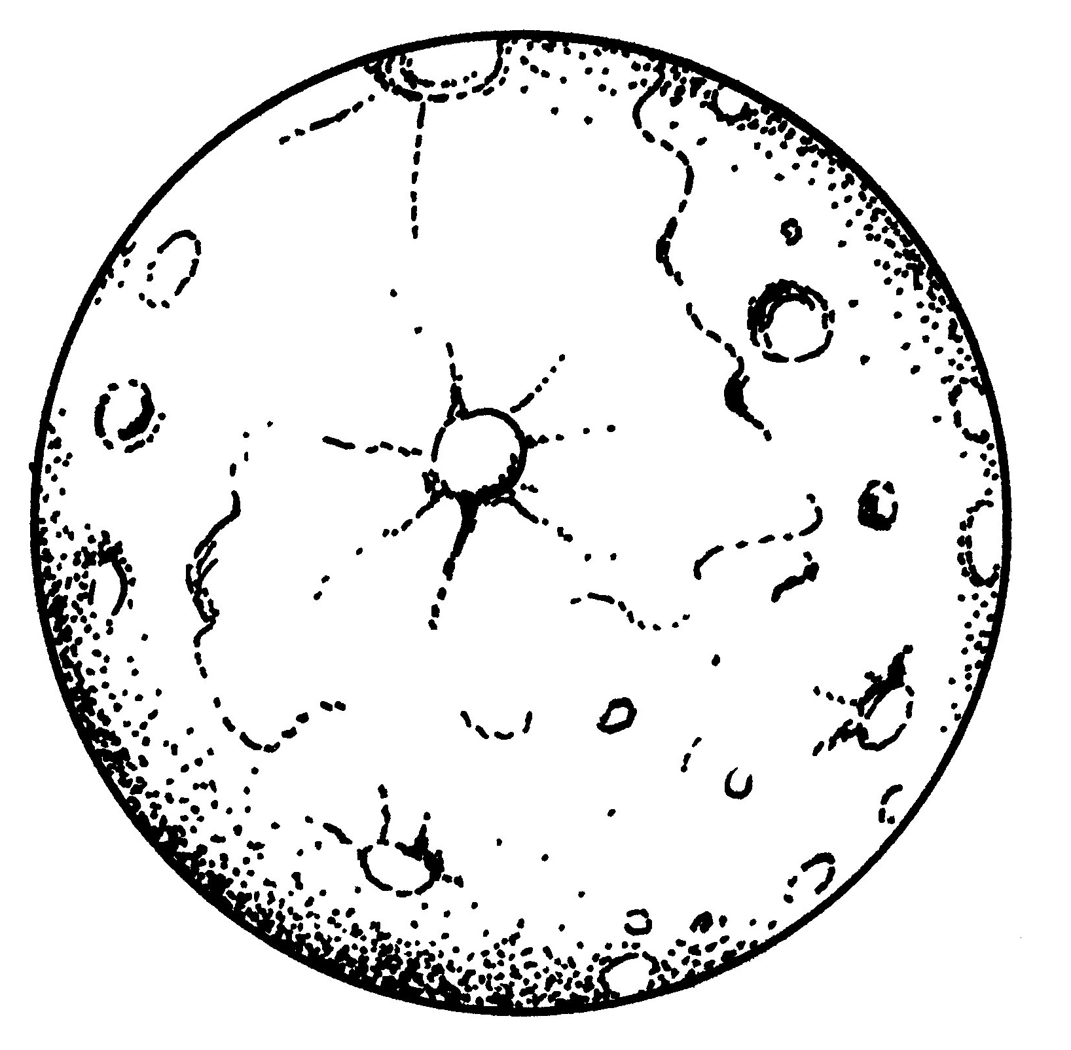 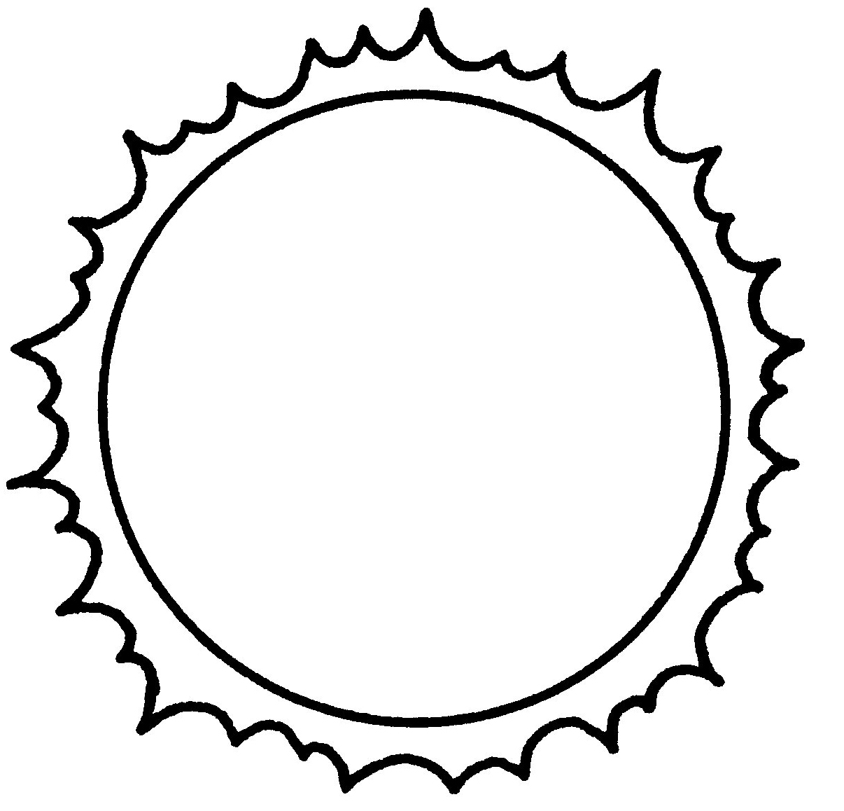

1. Circle the picture that shows an object that is near the girl.

