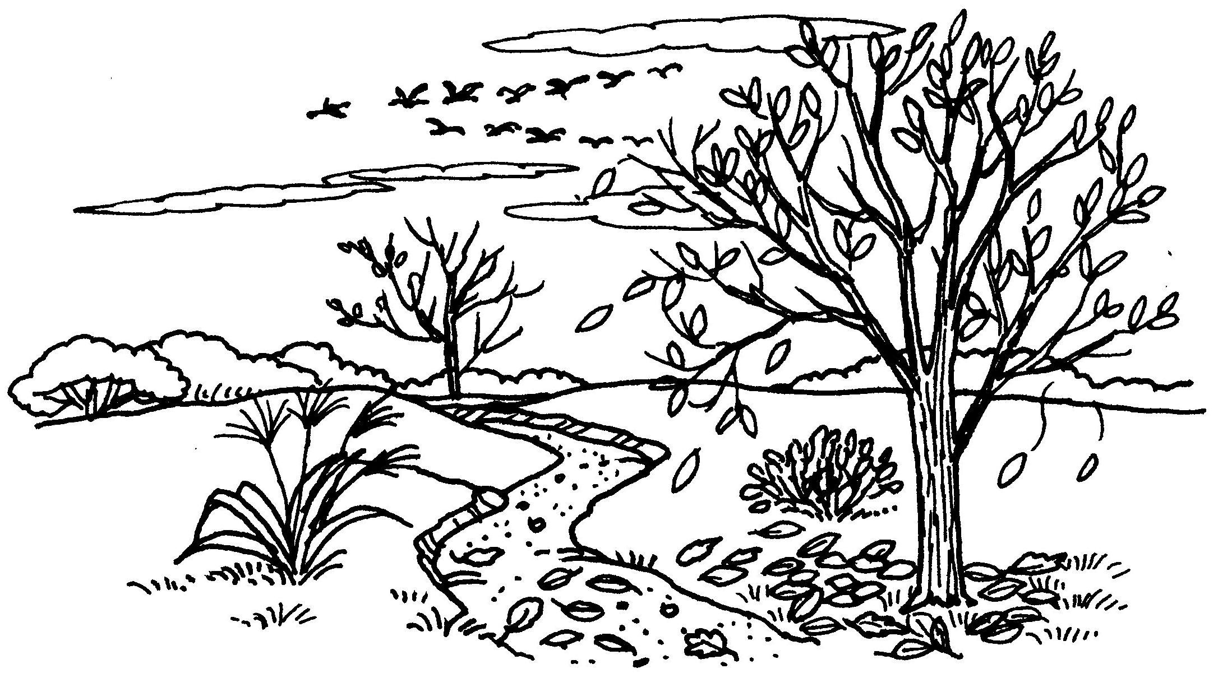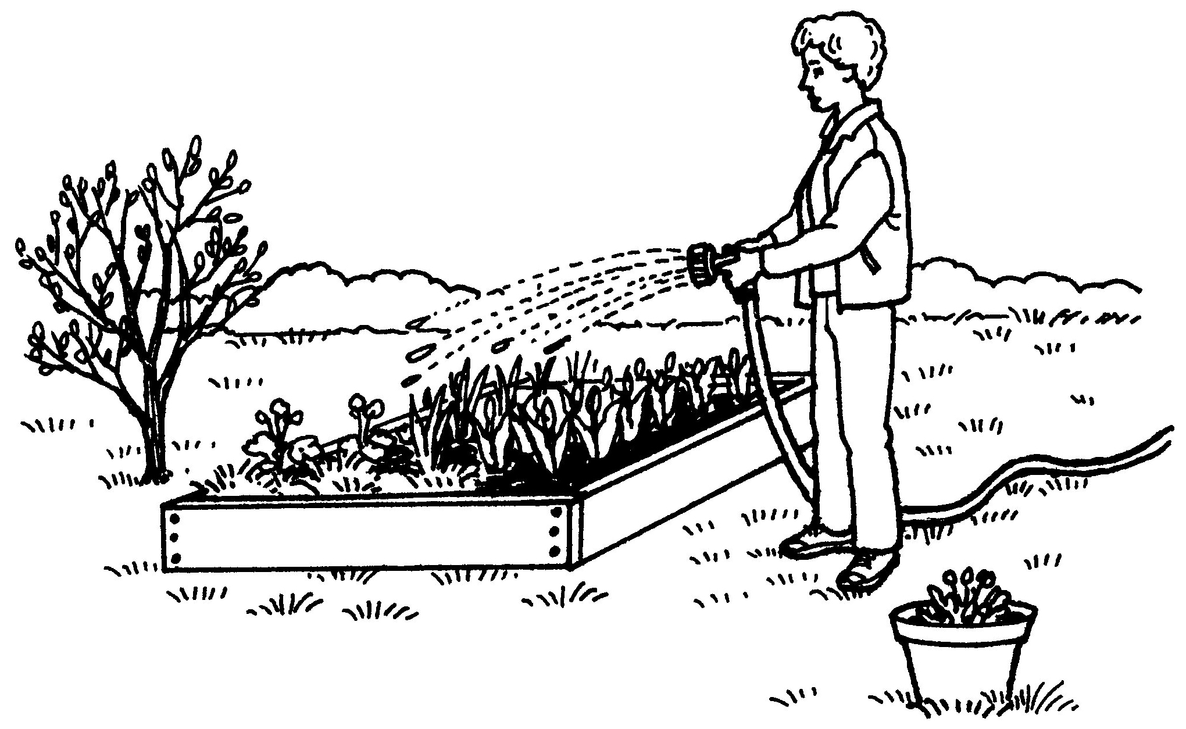Seasons of the Year

Multiple Choice.

- Circle the picture of the season that comes next.

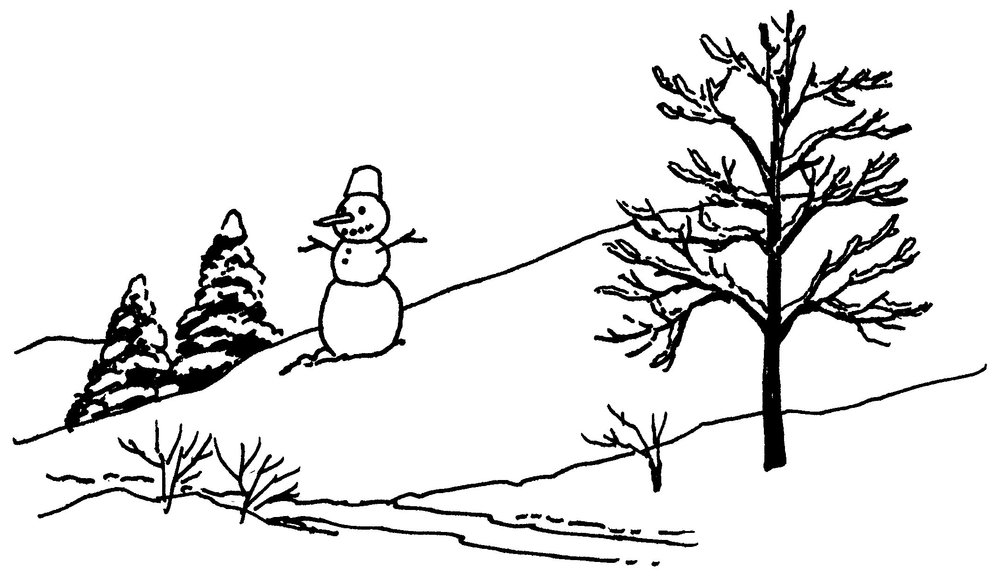

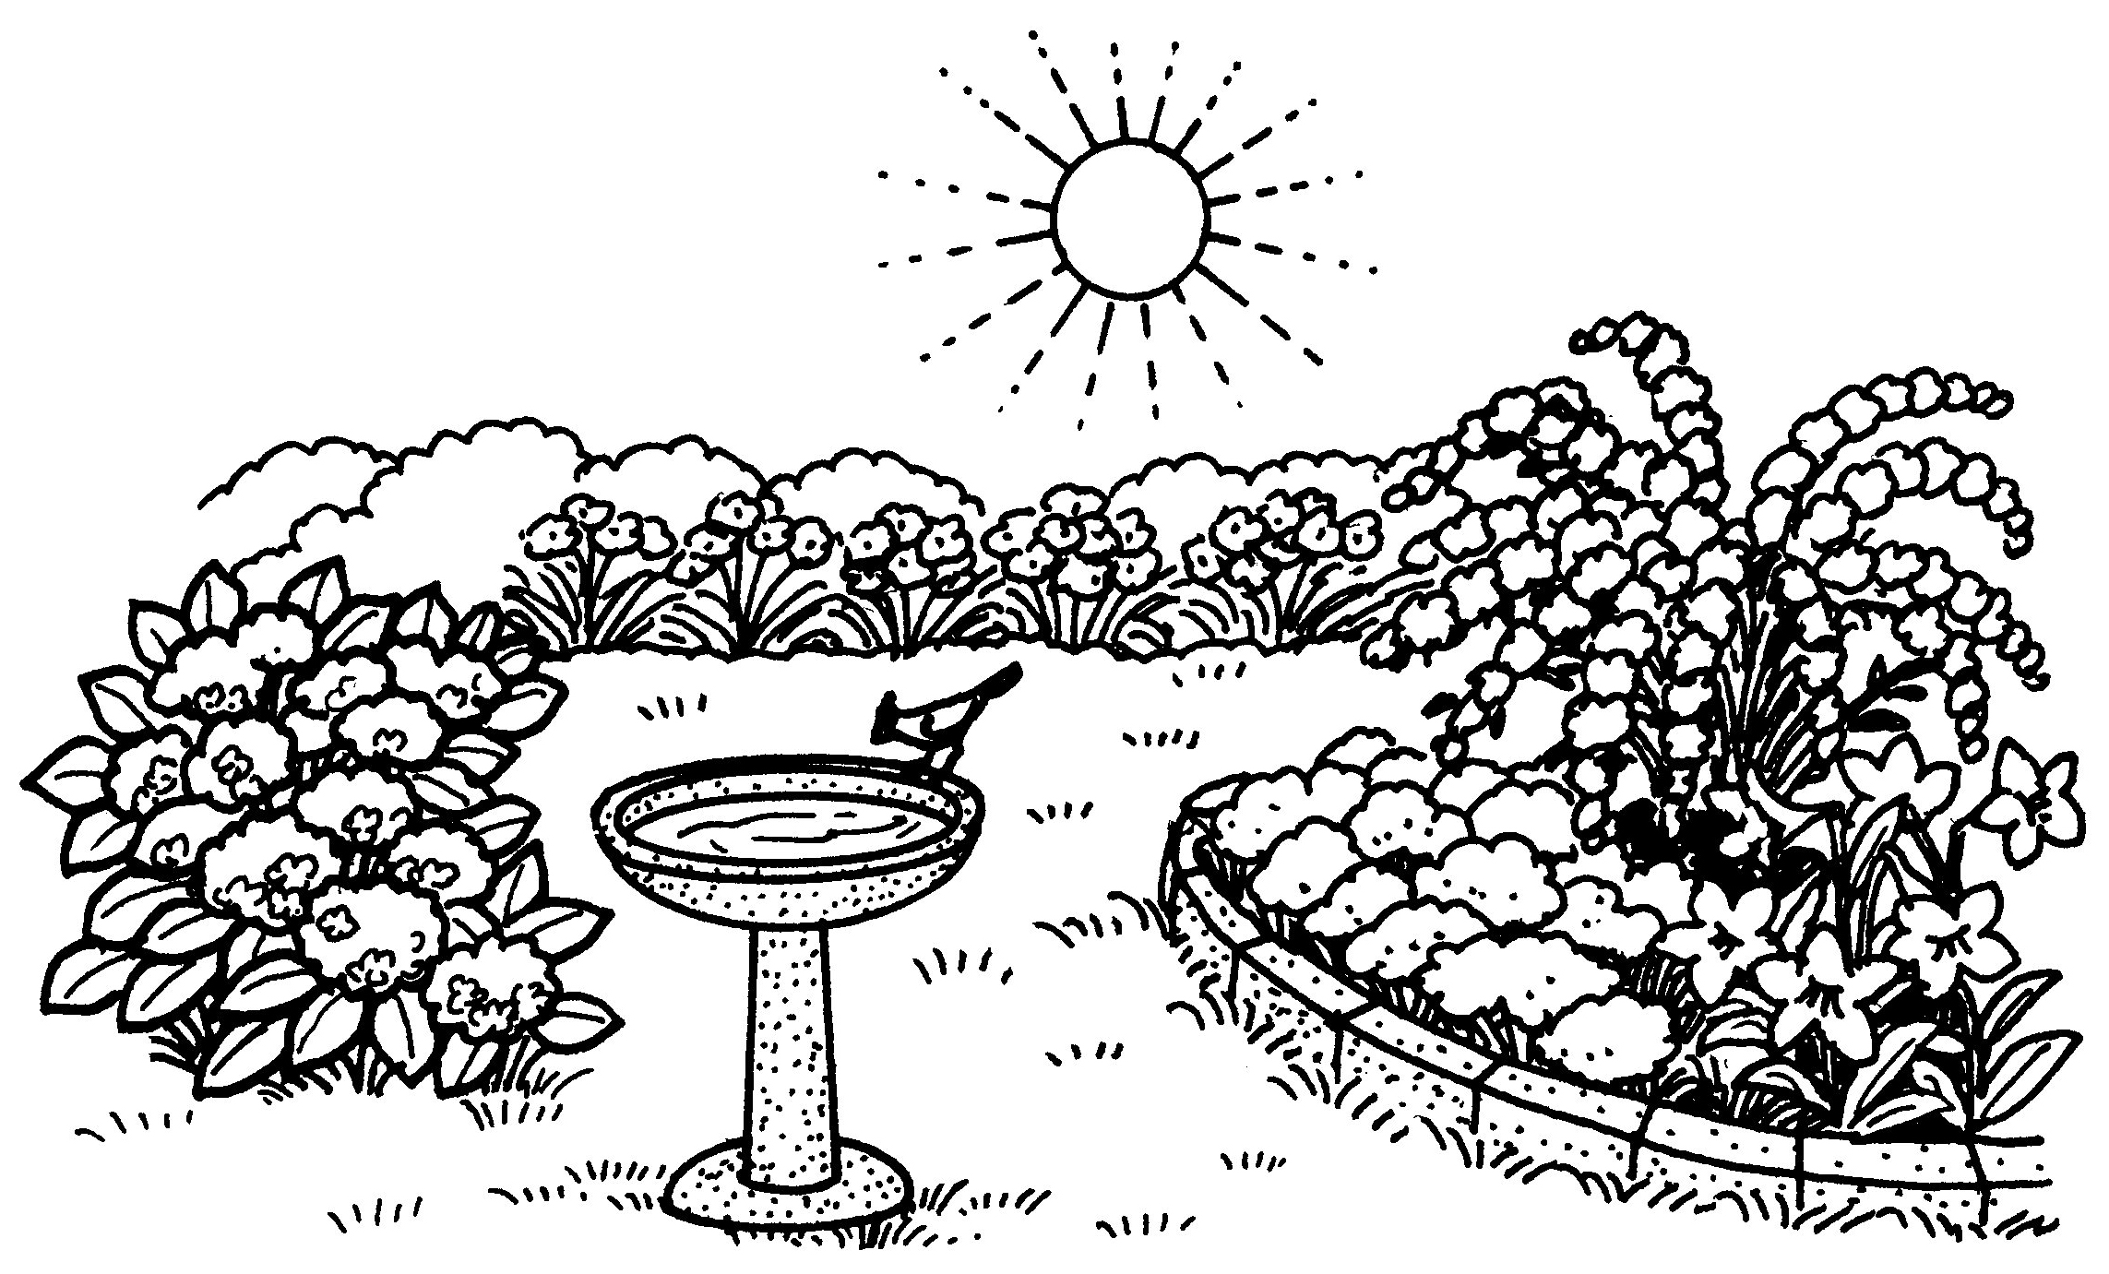
Summer

Winter

Fall

Spring

Seasons of the Year
- Circle the picture of the season that comes next.

Winter

Summer

Spring
Fall

Seasons of the Year
- Which do you see a lot of in the summer? Circle the picture.

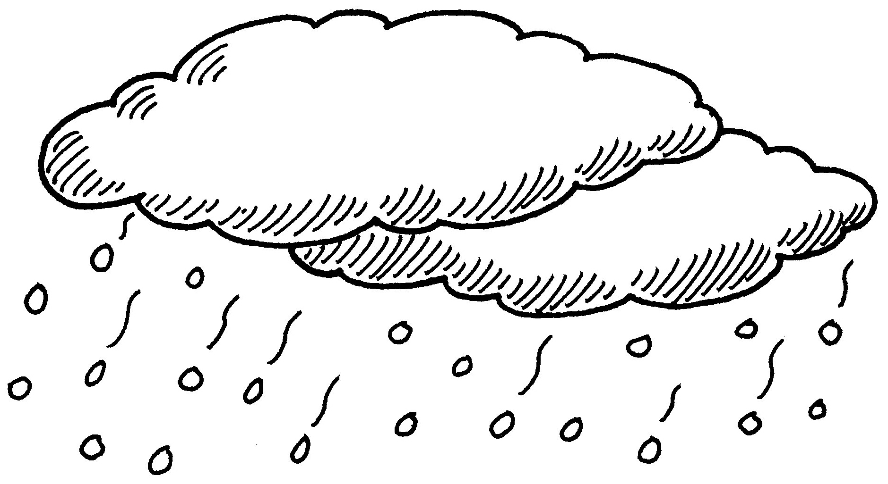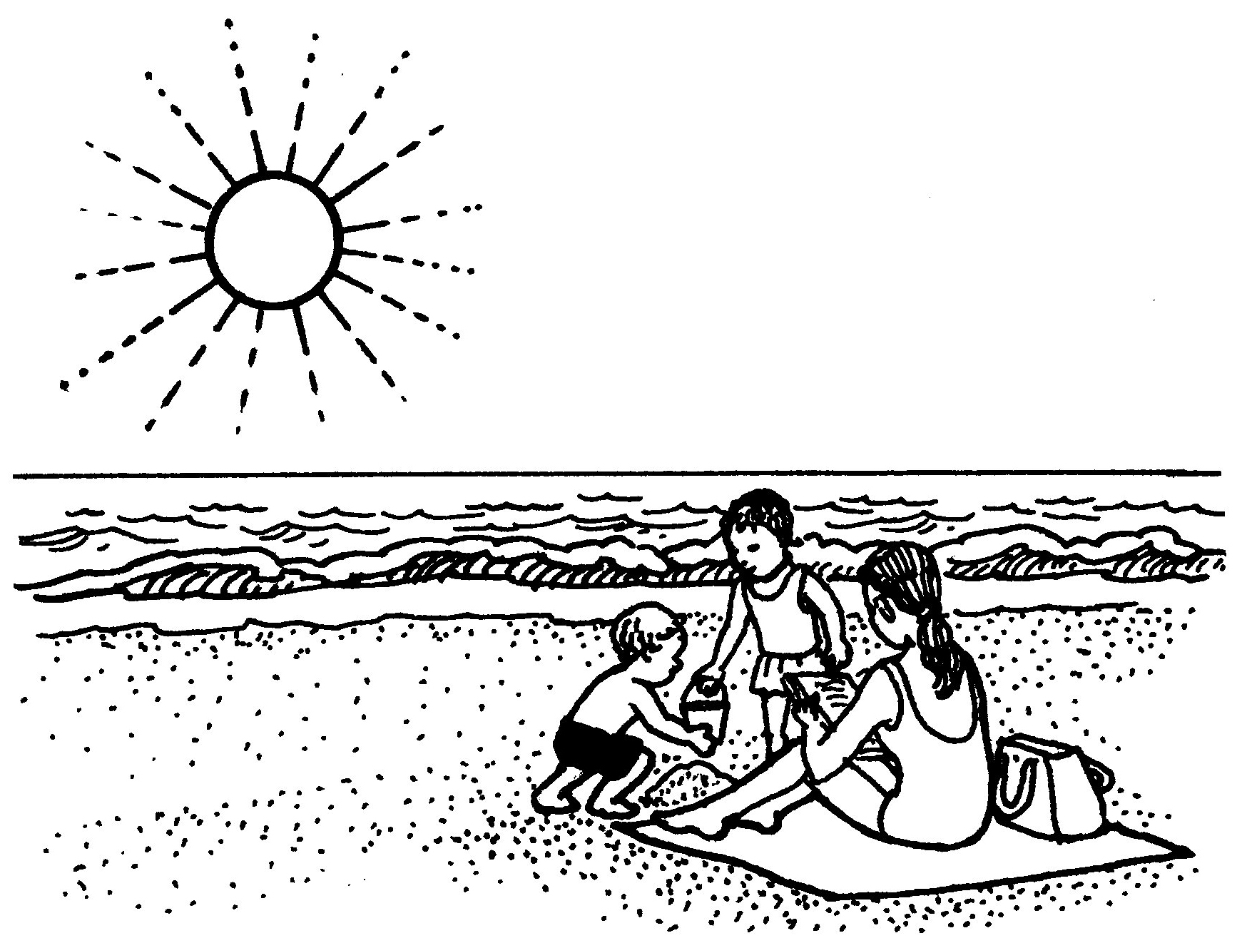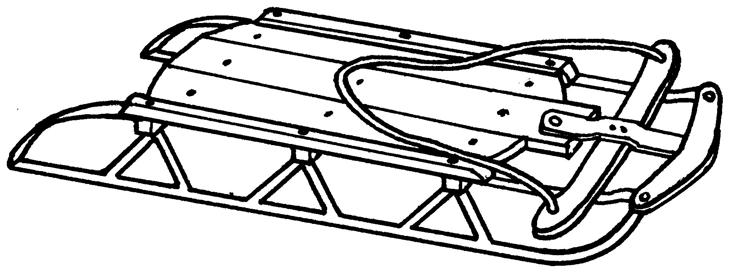

- What kind of weather do many people see during the spring? Circle the picture.

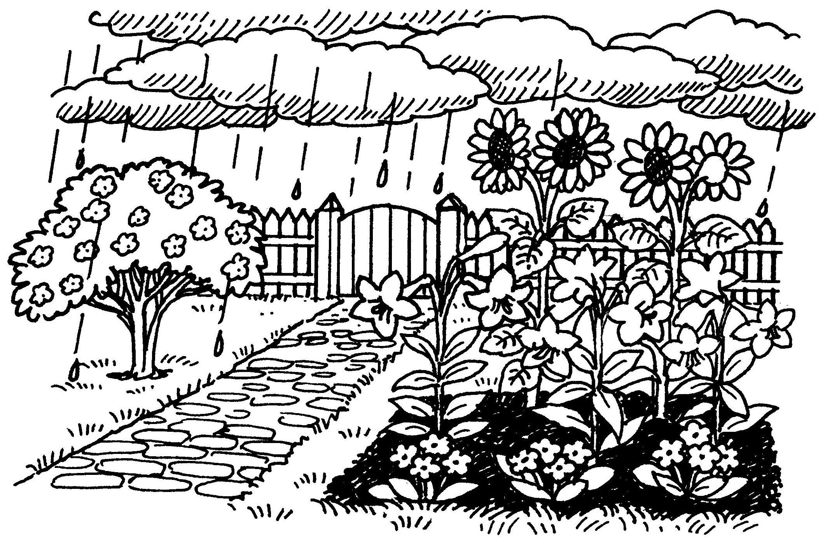

Seasons of the Year

- Which picture shows the season that begins each New Year? Circle the picture.

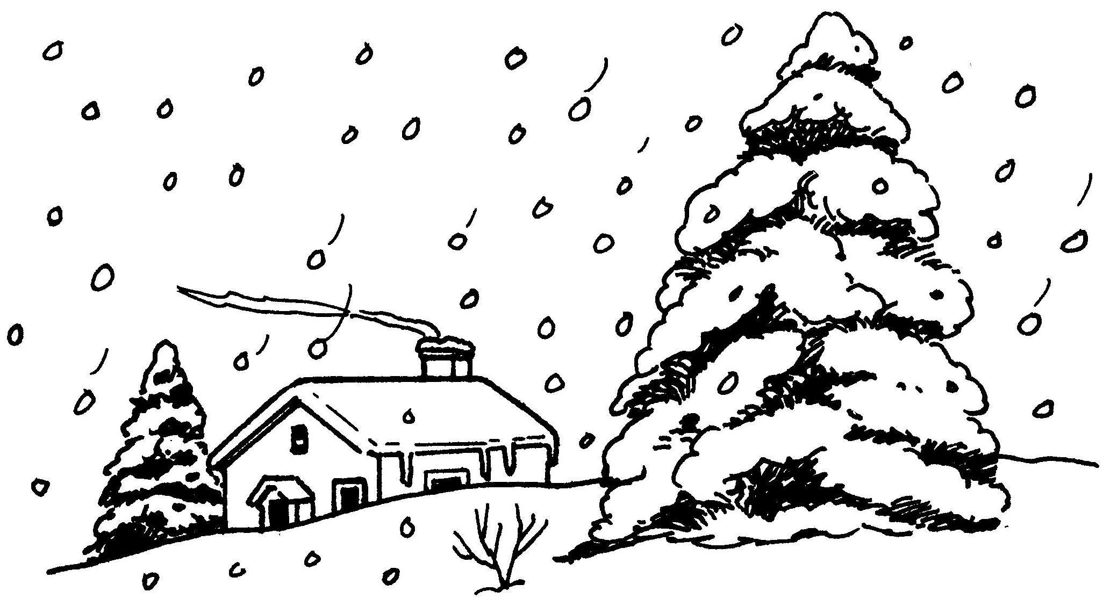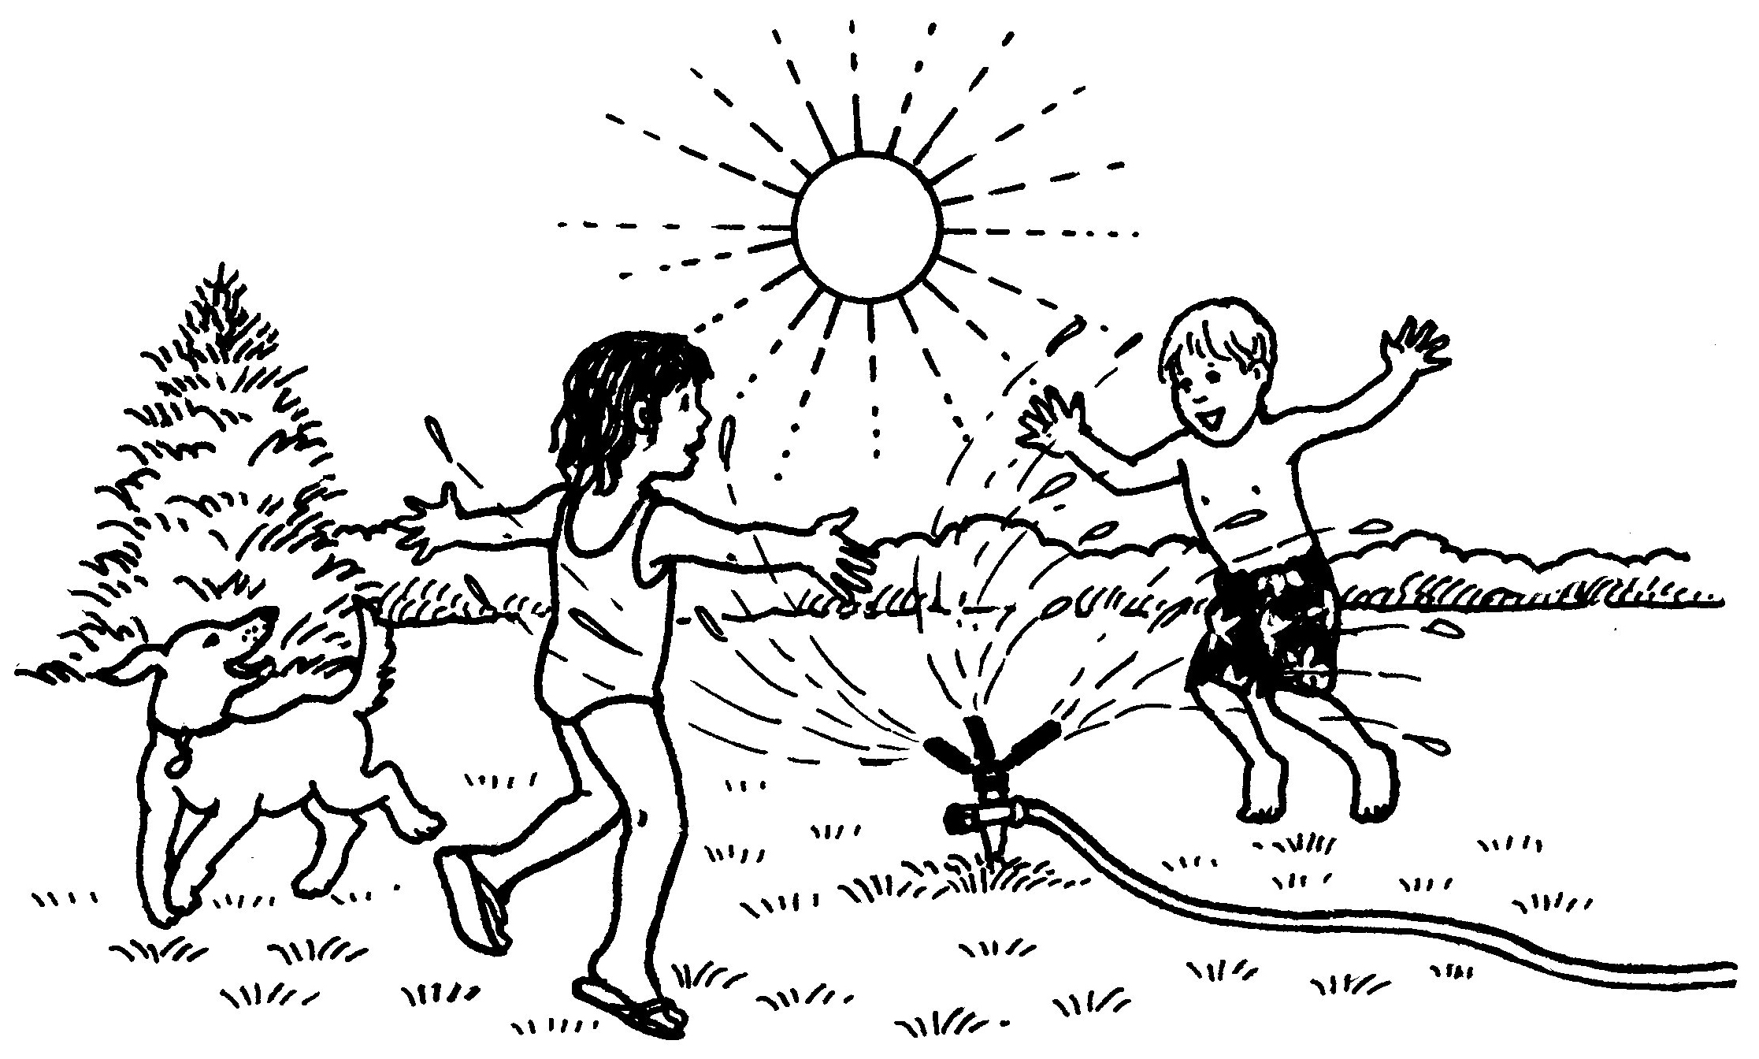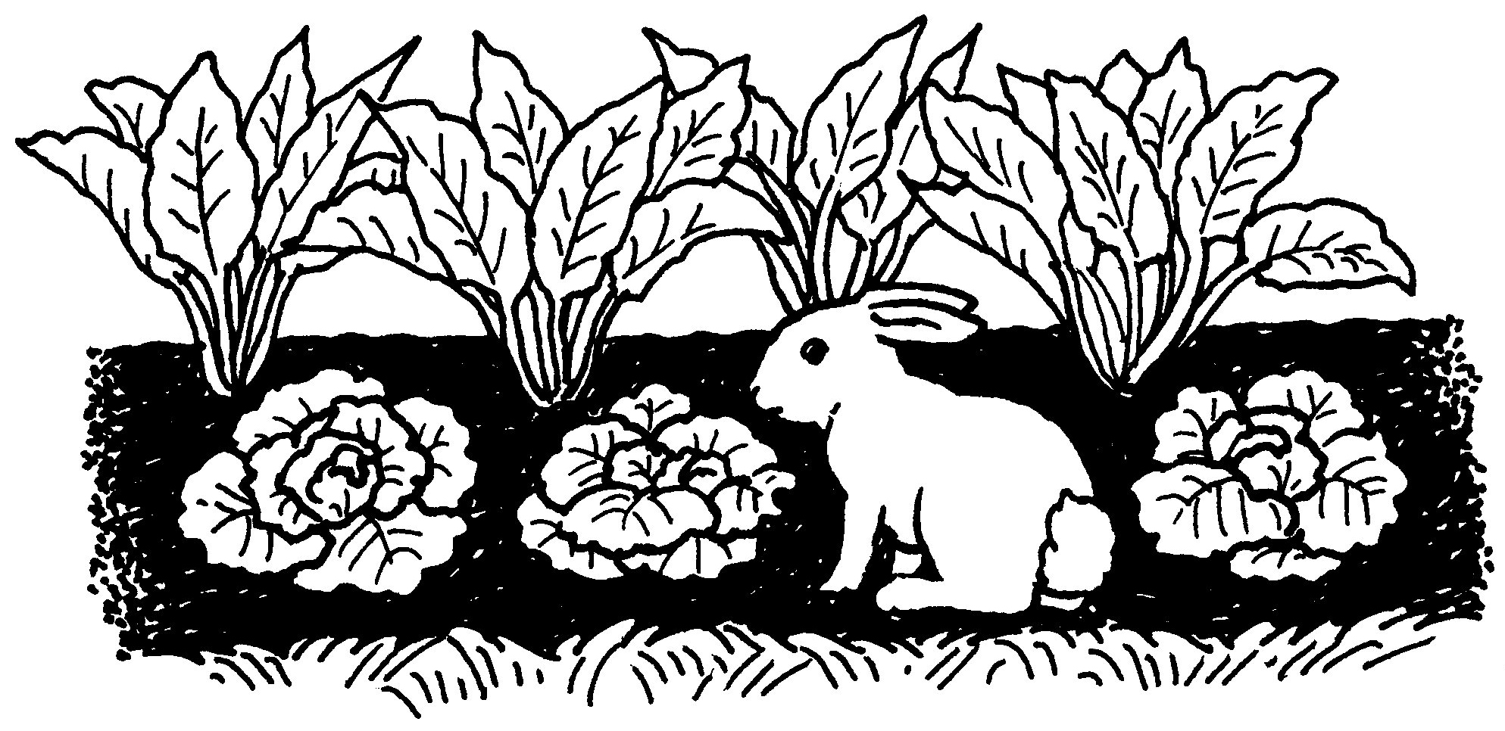

Seasons of the Year

Directions:
There are four seasons. They are: winter, spring, summer, and fall. Below each heading, draw a picture that shows what it looks like outside where you live during one season. Under the picture, write the name of the season and a few words to tell about it.

Winter | Summer

