Name: _______________________________________________

Draw a line to match the picture to the word.

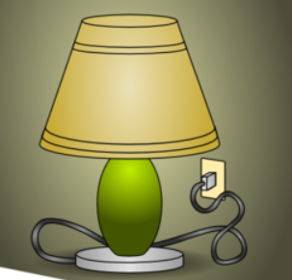
transparent
(see-through)

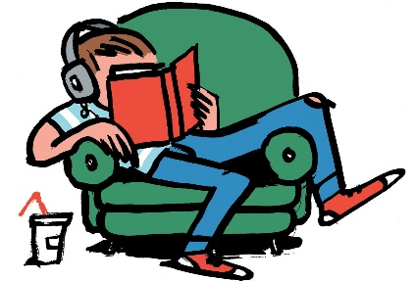
translucent
(kind of see-through)
opaque
(not see-through)

Name another transparent material.

Circle all of the places light is coming from.

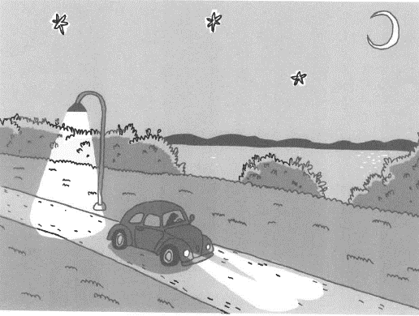

If light were not coming from any of those places, what would the driver see?

