Name: _______________________________________________

Draw a line to match the baby animal to the correct parent.

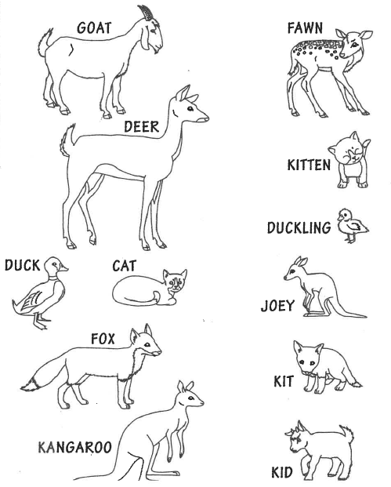

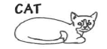

Draw a baby animal with its parents. Label your picture identifying the parent and the baby.

How is the baby animal similar to its parents?

