Grade 5 Unit 4 Patterns in the Night Sky
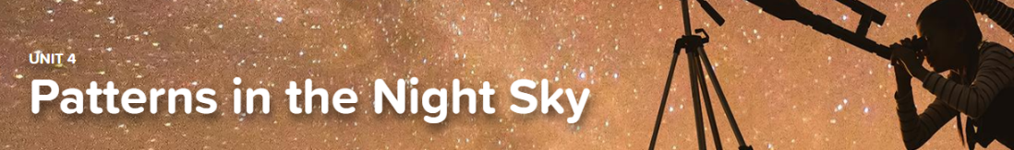

Concept 4.1 Effects of Gravity
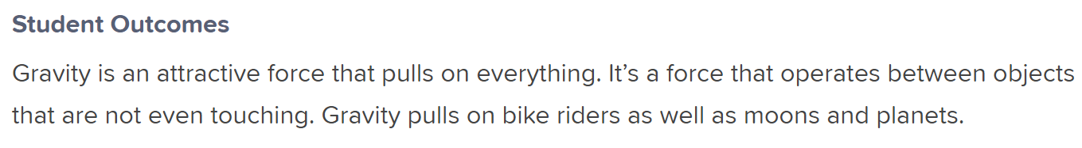
Interactive
Gravity
Exploration
Lose Weight without Dieting!

Concept 4.2 Patterns of Motion in the Sky
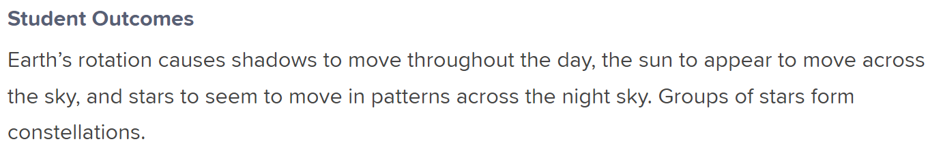
Interactives
Cycles in the Sky
Constellations
Virtual Lab
When’s the Shadow There

Concept 4.3 Sun and Star Brightness
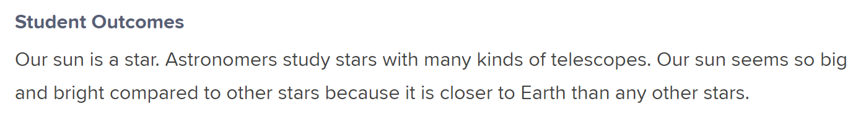
Interactives
Our Star the Sun
Your Place in Space

