Unit 3 Interacting Earth Systems
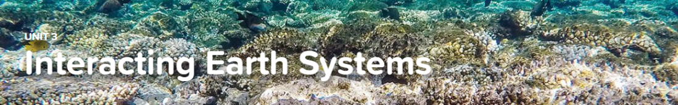

Concept 3.1 Hydrosphere and Biosphere Interactions
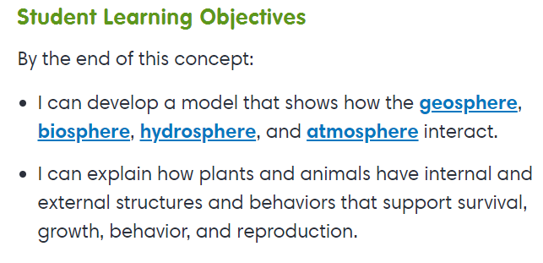
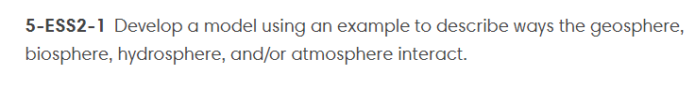
Virtual Lab
Pond-er This
Explorations
Water Ecosystems
The Atmosphere

Concept 3.2 Water as a Valuable Natural Resource
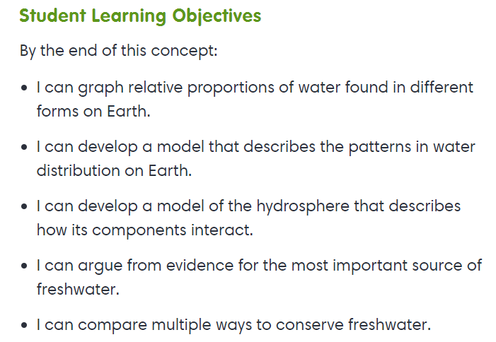
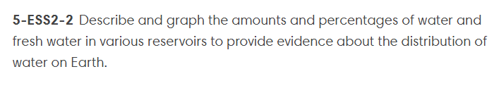
Interactive
Waters of the Earth
Explorations
Ocean Resources
Fresh Water

Concept 3.2 Protecting Earth’s Resources
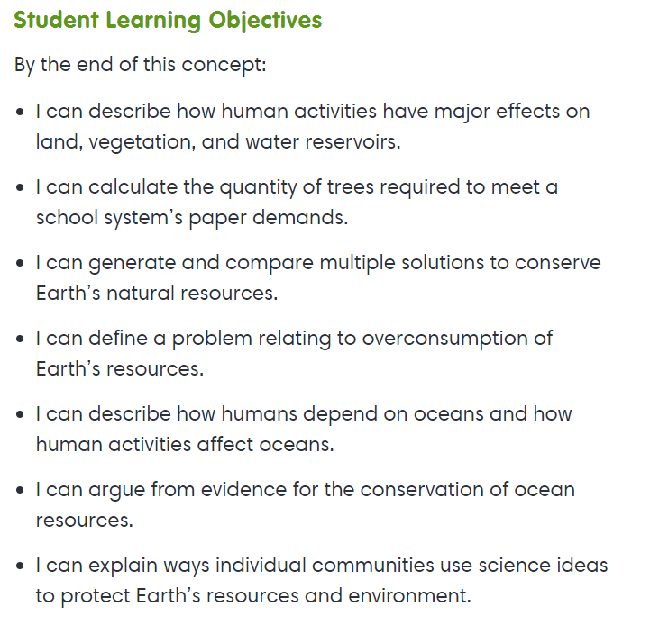
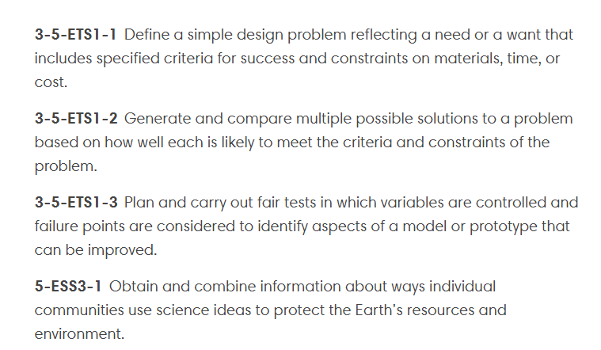
Interactives
Earth’s Resources
Value of Renewable Resources
Mineral Resources

