Grade 5 Unit 2: From Matter to Organisms
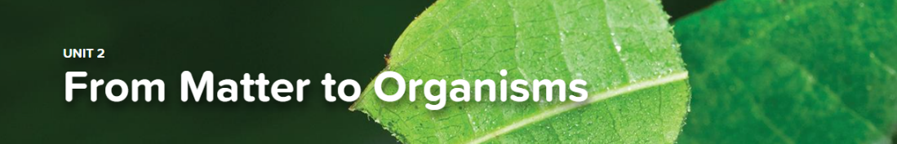

Concept 2.1 Plant Needs
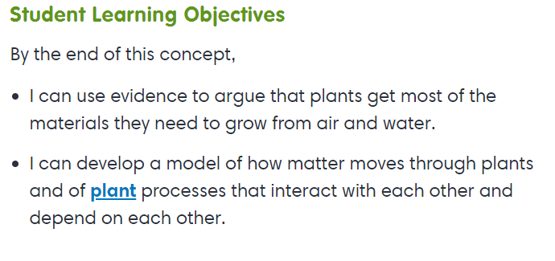
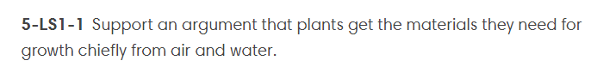
Interactives
Getting To Know Plants
Basic Needs
Virtual Labs
How Does Your Garden Grow
Leaves

Concept 2.2 Matter Flow in Ecosystems
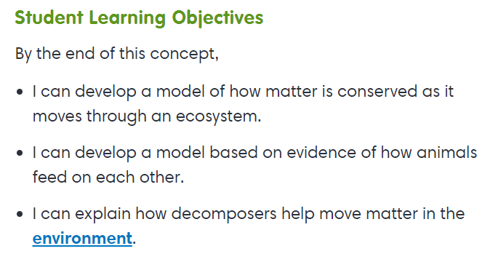
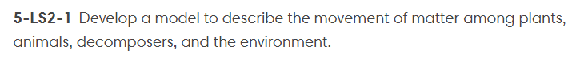
Interactives
Interactions in Ecosystems
Virtual Labs
Pond-er This
Parts of Ecosystems
Explorations
Who’s For Dinner
Decomposition

Concept 2.3 Energy Flow in Ecosystems
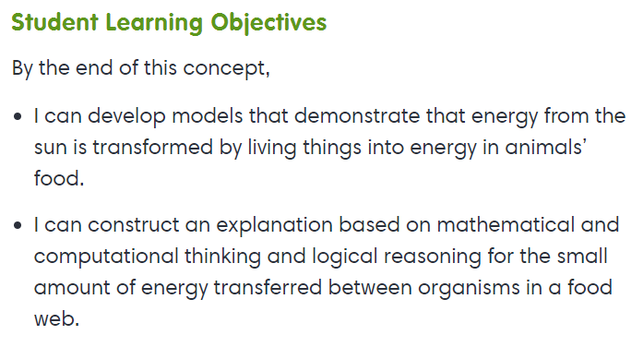
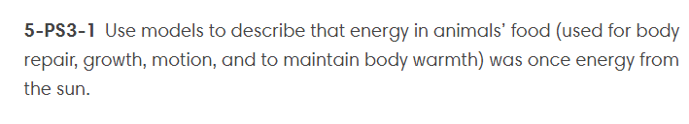
Explorations
Energy in Systems

