Grade 5 Unit 1 What Is Matter Made Of?
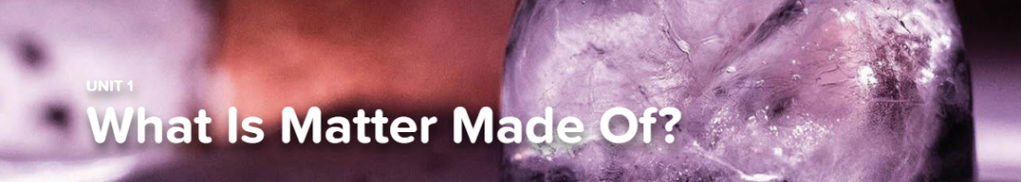

Concept 1.1 Describing Matter in Words and Numbers
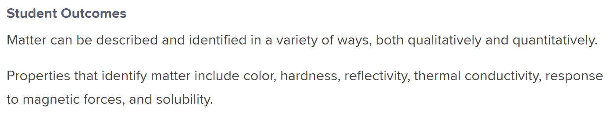
Fun-Damentals
What’s the Matter? Properties*
Interactive
Measuring Matter
Exploration
Three States of Matter

Concept 1.2 Changes to Matter
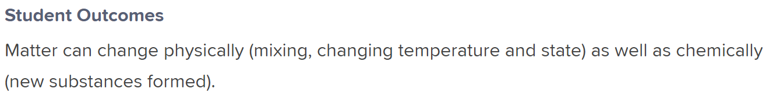
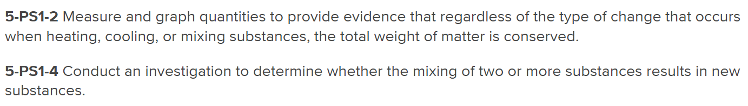
Fun-Damental
What’s the Matter? Changing States
Interactive
Things That Change
Explorations
Changes of States
Virtual Lab
Mixtures

Concept 1.3 A Model of Matter
Skill Builder
Properties of Matter: Particle Simulator
Explorations
Atoms
Changing States
Virtual Lab
Melt-Off*

