Discovery Education TechBook: National
Overview:
The National Version of TechBook was designed to be a more user friendly for both teachers and students.
- Each grade is divided into several Units.
- Each Unit is anchored in a phenomenon.
- Each Unit is divided into several Concepts.
- The Concepts are organized into Wonder, Learn and Share.
- Each Concept includes an introduction and an extension (Beyond).
Below details some of the components within the new TechBook:
START
- Go to Science TechBook
- Go to Course: Grade ___ National
Unit Level
Click View Unit
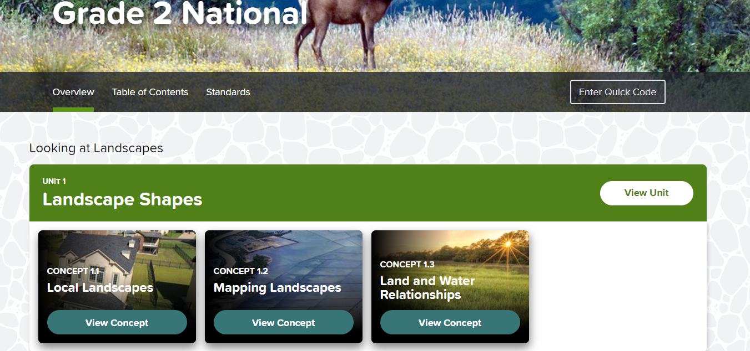
In the Unit Level:
  - Every Unit is anchored in phenomenon (which can be revisited throughout the unit)
  - Each Unit has a Unit Project
  - Each concept is listed under the unit
  - There is a performance assessment at the Unit Level (as well as in each of the concepts)
Concept Level
In the Concept Level:
- Each Concept has an investigative phenomenon (which can be revisited throughout the concept)
- Looks different: instead of 5 Es (Engage, Explore, Explain, Elaborate and Evaluate)- it is now Wonder, Learn and Share
- Enter Quick Code is a direct link to the print version. If you enter the code from the book- it will bring you directly to the page in the digital version

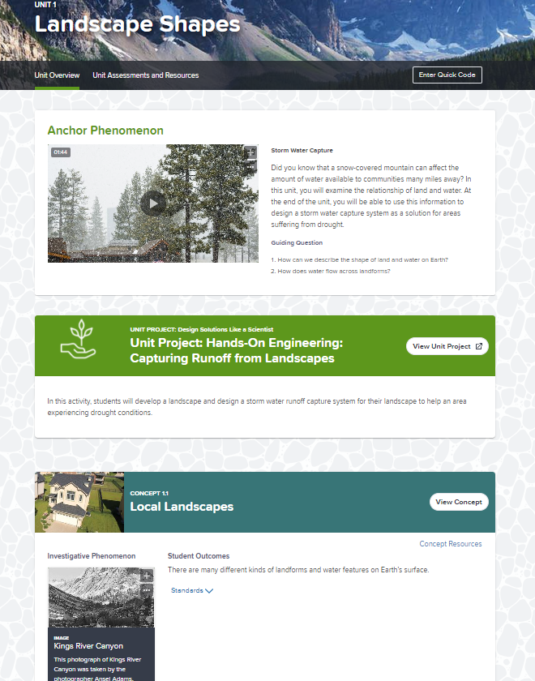
e
c
b
a
d
g
f

- Intro: (Highlight the difference between the teacher view and the student view)
  - Teacher planning resources are front and center (literacy connections, vocabulary, pacing)
  - Learning objectives
  - I Can Statements
- Wonder
  - Organized by Activities
  - Activities at a glance: lists the time it takes to do the activity, objectives and standards
  - Inside the activities, you should notice:
    - SEP (Science Engineering Practice)
    - Less text
    - Bold- what are we expecting students to do
    - Links to the text (gives teachers the options to have students respond digitally or print off)
    - Speak text- right click
    - Lots of teacher support: questions, activators, ability to edit activities etc..
- Learn
  - Activities are organized by guiding questions
  - Interactives are usually found here
  - SOS- Spotlight on Strategies- some are embedded right within the TechBook
- Share
  - Lots of talking and sharing opportunities
  - Analyze like a scientist, evaluate like a scientist
  - Project extensions
  - Use whiteboard within TechBook for drawing and quick uploading
- Beyond
  - Additional resources and extensions
  - Projects

Other:
- Additional resources from the home screen (black history month, Super Bowl)
- Directly connects to Schoology- complete integration
- Students can answer directly in the digital version (teacher can get analytics) or teachers can print student pages
- In the print version:
  - Grade-level Scope and Sequence for the year
  - List of hands on activities and the supplies needed
  - Additional pacing supports
Links to the training audio:
Kindergarten and Grade 1 Training
Grades 4 and 5 Training
Grade 2 and Grade 3 training

